

**2018** 年全国卷Ⅰ

During my second year at the city college ，I was told that the education department was offering a "free"course, called Thinking Chess, for three credits.I 41 the idea of taking the class because, after all ,who doesn't want to 42 a few dollars? More than that, I'd always wanted to learn chess. And,even if I weren’t 43 enough about free credits,news about our 44 was appealing enough to me. He was an international grandmaster, which 45 I would be learning from one of the game's 46 .I could hardly wait to 47 him.

Maurice Ashley was kind and smart, a former graduate returning to teach, and this 48 was no game for him: he meant business. In his introduction, he made it 49 that our credits would be hard-earned. In order to 50 the class ,among other criteria, we had to write a paper on how we plan to 51 what we would learn in class to our future professions and, 52 ,to our lives. I managed to get an A in that 53 and learned life lessons that have served me well beyond the 54 .

54. A. criterion B. classroom C. department D. situation

55. A. taught B. wrote C. questioned D. promised

56. A. fact B. step C. manner D. skill

57. A. grades B. decisions C. impressions D. comments

58. A. analyze B. describe C. rebuild D. control

59. A. announce B. signal C. block D. evaluate

60. A. role B. desire C. concern D. behavior

Ten years after my chess class with Ashley, I'm still putting to use what he 55 me“:

The absolute most important 56

that you learn when you play chess is how to make good 57 .On every single move you have to 58 a situation ,process what your opponent(对手）is doing and 59 the best move from among all your options.”These words still ring true today in my 60 as a journalist.

|  |  |  |  |  |  |  |  |
| --- | --- | --- | --- | --- | --- | --- | --- |
| 41. A. put forward | B. jumped at | C. tried out | D. turned down |  | | | |
| 42. A. waste | B. earn | C. save | D. pay |  |  |  |  |
| 43. A. excited | B. worried | C. moved | D. tired |  |  |  |  |
| 44. A. title | B. competitor | C. textbook | D. instructor |  |  |  |  |
| 45. A. urged | B. demanded | C. held | D. meant |  |  |  |  |
| 46. A. fastest | B. easiest | C. best | D. rarest |  |  |  |  |
| 47.A. interview | B. meet | C. challenge | D. beat |  |  |  |  |
| 48. A. chance | B. qualification | C. honor | D. job |  |  |  |  |
| 49. A. real | B. perfect | C. clear | D. possible |  |  |  |  |
| 50. A. attend | B. pass | C. skip | D. observe |  |  |  |  |
| 51. A. add | B. expose | C. apply | D. compare |  |  |  |  |
| 52. A. eventually | B. naturally | C. directly | D. normally |  |  |  |  |
| 53. A. game | B. presentation | C. course | D. experiment | 41-45BCADD | 46-50CBDCB | 51-55CACBA | 56-60DBADA |

**2018** 年全国卷Ⅱ

Two weeks earlier, my son, Ben, had got in touch. He’d moved to England with his mum when he was three and it had been 13 years since I’d 41 seen him. So imagine my 42 when he emailed me saying he wanted to come to visit me.

I was 43 ! I arrived early at Byron Bay where we were supposed to 44 . The bay was 45 in sunshine, and there was a group of kayakers around 150m off the shore. Getting a little 46 , I realized one kayak（皮划艇） was in 47 . ＂Something’s not 48 !＂ I took off my T-shirt and 49 into the water. I saw there were two

instructors on board and a man lying across the middle. He was 50 violently. Linking arms with one of the instructors. I helped 51 the young man out of the water. He was unconscious and as I looked at his face, something

52 to me. Those brown eyes were very 53 . ＂What’s his name?＂ I asked the instructor. ＂Ben,＂ he replied,

and immediately I 54 . That stranger was my son!

The instructors called for an ambulance. 55 , after a brief stay in hospital, Ben was well enough to be allowed to 56 and later the family met up for dinner. We chatted about everything and then Ben 57 to me. ＂I just want to say thank you,＂ he said. ＂You 58 my life!＂

I still can’t believe what a 59 it was. I’m just so glad I was there 60 to help my son.

54. A. agreed B. hesitated C. doubted D. knew

55. A. Fortunately B. Frankly C. Sadly D. Suddenly

56. A. return B. relax C. speak D. leave

57. A. joked B. turned C. listened D. pointed

58. A. created B. honored C. saved D. guided

59. A. coincidence B. change C. pity D. pain

60. A. on board B. in time C. for sure D. on purpose

|  |  |  |  |  |  |  |  |
| --- | --- | --- | --- | --- | --- | --- | --- |
| 41. A. also | B. often | C. even | D. last |  | | | |
| 42. A. delight | B. relief | C. anger | D. worry |  |  |  |  |
| 43. A. scared | B. shocked | C. thrilled | D. ashamed |  |  |  |  |
| 44. A. talk | B. stay | C. meet | D. settle |  |  |  |  |
| 45. A. bathed | B. clean | C. deep | D. formed |  |  |  |  |
| 46. A. faster | B. closer | C. heavier | D. wiser |  |  |  |  |
| 47. A. trouble | B. advance | C. question | D. battle |  |  |  |  |
| 48. A. real | B. right | C. fair | D. fit |  |  |  |  |
| 49. A. stared | B. sank | C. dived | D. fell |  |  |  |  |
| 50. A. arguing | B. fighting | C. shouting | D. shaking |  |  |  |  |
| 51. A. lead | B. persuade | C. carry | D. keep |  |  |  |  |
| 52. A. happened | B. occurred | C. applied | D. appealed |  |  |  |  |
| 53. A. sharp | B. pleasant | C. attractive | D. familiar | 41-45DACCA | 46-50BABCD | 51-55CBDDA | 56-60DBCAB |

**2018** 年全国卷Ⅲ

|  |  |  |  |
| --- | --- | --- | --- |
| 52. A. dream | B. promise | C. agenda | D. principle |
| 53. A. bearing | B. collecting | C. opening | D. making |
| 54. A. discouraged | B. relaxed | C. astonished | D. defeated |
| 55. A. admit | B. need | C. appreciate | D. expect |
| 56. A. found | B. selected | C. developed | D. posted |
| 57. A. confirmed | B. simplified | C. clarified | D. accompanied |
| 58. A. pity | B. blessing | C. relief | D. problem |
| 59. A. smart | B. calm | C. sweet | D. fair |
| 60. A. sympathy | B. attention | C. control | D. trust |

When most of us get a text message on our cell phone from an unknown person, we usually say ＂sorry,

41 number!＂ and move on. But when Dennis Williams 42 a text that clearly wasn’t intended for him, he did something 43 .

On March 19, Dennis got a group text 44 him that a couple he didn’t know were at the hospital, waiting for the 45 of a baby.

＂Congratulations! But I think someone was mistaken,＂ Dennis 46 . The baby was born and update texts

were 47 quickly from the overjoyed grandmother, Teresa. In her 48 , she didn’t seem to realize that she was 49 the baby’s photos with a complete stranger. ＂Well, I don’t 50 you all but I will get there to take pictures with the baby,＂ replied Dennis before asking which room the new 51 were in.

Much to the family’s surprise, Dennis stuck to his 52 ! He turned up at the hospital 53 gifts for the new mother Lindsey and her baby boy. Lindsey’s husband was totally 54 by the unexpected visit. ＂I don’t think we would have randomly invited him over but we 55 it and the gifts.＂

Teresa 56 a photo of the chance meeting on a social networking website 57 by the touching words: ＂

What a 58 this young man was to our family! He was so 59 and kind to do this.＂ The post has since gained the 60 of social media users all over the world, receiving more than 184,000 shares and 61,500 likes in

|  |  |  |  |  |  |  |  |
| --- | --- | --- | --- | --- | --- | --- | --- |
| just three days. |  |  |  |  | | | |
| 41. A. unlucky | B. secret | C. new | D. wrong |
| 42. A. received | B. translated | C. copied | D. printed |  |  |  |  |
| 43. A. reasonable | B. special | C. necessary | D. practical |  |  |  |  |
| 44. A. convincing | B. reminding | C. informing | D. warning |  |  |  |  |
| 45. A. wake-up | B. recovery | C. growth | D. arrival |  |  |  |  |
| 46. A. responded | B. interrupted | C. predicted | D. repeated |  |  |  |  |
| 47. A. coming in | B. setting out | C. passing down | D. moving around |  |  |  |  |
| 48. A. opinion | B. anxiety | C. excitement | D. effort |  |  |  |  |
| 49. A. comparing | B. exchanging | C. discussing | D. sharing |  |  |  |  |
| 50. A. accept  51. A. parents | B. know  B. doctors | C. believe  C. patients | D. bother  D. visitors | 41—45 DABCD | 46—50 AACDB | 51—55 ABACC | 56—60 DDBCB |

**2018** 年北京卷

**The Homeless Hero**

|  |  |  |  |
| --- | --- | --- | --- |
| 18. A. wallet | B. bag | C. box | D. parcel |
| 19. A. partner | B. colleague | C. owner | D. policeman |
| 20. A. turned | B. hid | C. stepped | D. reached |
| 21. A. discover | B. collect | C. check | D. believe |
| 22. A. taking | B. leaving | C. reading | D. writing |
| 23. A. satisfied | B. excited | C. amused | D. shocked |
| 24. A. safe | B. missing | C. found | D. seen |
| 25. A. service | B. support | C. kindness | D. encouragement |
| 26. A. when | B. if | C. where | D. because |
| 27. A. rather | B. yet | C. already | D. just |
| 28. A. too | B. though | C. again | D. instead |
| 29. A. honest | B. polite | C. rich | D. generous |
| 30. A. gave | B. paid | C. cast | D. drew |
| 31. A. learned | B. posted | C. cared | D. heard |
| 32. A. borrow | B. raise | C. save | D. earn |
| 33. A. of | B. at | C. for | D. in |
| 34. A. details | B. changes | C. offers | D. applications |
| 35. A. lesson | B. adventure | C. chance | D. challenge |

For many, finding an unattended wallet filled with £400 in cash would be a source（来源）of temptation（诱惑）. But

the 16 would no doubt be greater if you were living on the streets with little food and money. All of this makes the actions of the homeless Tom Smith 17 more remarkable.

After spotting a 18 on the front seat inside a parked car with its window down, he stood guard in the rain for about two hours waiting for the 19 to return.

After hours in the cold and wet, he 20 inside and pulled the wallet out hoping to find some ID so he could contact（联系）the driver, only to 21 it contained £400 in notes, with another £50 in spare change beside it.

He then took the wallet to a nearby police station after 22 a note behind to let the owner know it was safe. When the car’s owner John Anderson and his colleague Carol Lawrence returned to the car—which was itself worth £35,

000—in Glasgow city centre, they were 23 to find two policemen standing next to it. The policemen told them what Mr. Smith did and that the wallet was 24 .

The pair were later able to thank Mr. Smith for his 25 .

Mr. Anderson said: ＂ I couldn’t believe that the guy never took a penny. To think he is sleeping on the streets tonight 26 he could have stolen the money and paid for a place to stay in. This guy has nothing and 27

he didn’t take the wallet for himself；he thought about others 28 . It’s unbelievable. It just proves there are 29

guys out there.＂

Mr. Smith’s act 30 much of the public’s attention. He also won praise from social media users after Mr. Anderson 31 about the act of kindness on Facebook.

Now Mr. Anderson has set up an online campaign to 32 money for Mr. Smith and other homeless people in the area, which by yesterday had received £8,000. ＂I think the faith that everyone has shown 33 him has touched him. People have been approaching him in the street; he’s had job 34 and all sorts, ＂ Mr. Anderson

commented.

For Mr. Smith, this is a possible life-changing 35 . The story once again tells us that one good turn deserves

16-20CBACD 21-25ABDAC 26-30ABDAD 31-35BBDCC

|  |  |  |  |
| --- | --- | --- | --- |
| another. |  | | |
| 16. A. hope | B. aim | C. urge | D. effort |
| 17. A. still | B. even | C. ever | D. once |

**2018** 天津卷

|  |  |  |  |
| --- | --- | --- | --- |
| 24. A. decision | B. attitude | C. conclusion | D. intention |
| 25. A. pride | B. culture | C. fortune | D. relationship |
| 26. A. leaders | B. partners | C. winners | D. learners |
| 27. A. rewards | B. vacations | C. health | D. honor |
| 28. A. risked | B. missed | C. considered | D. practiced |
| 29. A. defeat | B. decline | C. accident | D. mistake |
| 30. A. relax | B. improve | C. expand | D. defend |
| 31. A. shame | B. burden | C. victory | D. favor |
| 32. A. chances | B. thrills | C. concerns | D. offers |
| 33. A. surprise | B. serve | C. interest | D. affect |
| 34. A. encouraged | B. observed | C. protected | D. impressed |
| 35. A. honestly | B. individually | C. calmly | D. differently |

No one is born a winner. People make themselves into winners by their own 16 .

I learned this lesson from a(n) 17 many years ago. I took the head 18 job at a school in Baxley, Georgia. It was a small school with a weak football program.

It was a tradition for the school’s old team to play against the 19 team at the end of spring practice. The old team had no coach, and they didn’t even practice to 20 the game. Being the coach of the new team, I was excited because I knew we were going to win, but to my disappointment we were defeated. I couldn’t 21 I had got into such a situation. Thinking hard about it, I came to 22 that my team might not be the number one team in Georgia, but they were 23 me. I had to change my 24 about their ability and potential.

I started doing anything I could to help them build a little 25 . Most important, I began to treat them like

26 . That summer, When the other teams enjoyed their 27 , we met every day and 28 passing and kicking the football.

Six months after suffering our 29 on the spring practice field, we won our first game and our second, and continued to 30 . Finally, we faced the number one team in the state. I felt that it would be a 31 for us even if we lost the game. But that wasn’t what happened. My boys beat the best team in Georgia, giving me one of the greatest

32 of my life!

From the experience I learnt a lot about how the attitude of the leader can 33 the members of a team. Instead of seeing my boys as losers, I pushed and 34 them. I helped them to see themselves 35 , and they built themselves into winners.

Winners are made, but born.

16-20CBDDB 21-25AACBA 26-30CBDAB 31-35CBDAD

|  |  |  |  |
| --- | --- | --- | --- |
| 16. A. luck | B. tests | C. efforts | D. nature |
| 17. A. experiment | B. experience | C. visit | D. show |
| 18. A. operating | B. editing | C. consulting | D. coaching |
| 19. A. successful | B. excellent | C. strong | D. new |
| 20. A. cheer for | B. prepare for | C. help with | D. finish with |
| 21. A. believe | B. agree | C. describe | D. regret |
| 22. A. realize | B. claim | C. permit | D. demand |
| 23. A. reacting to | B. looking for | C. depending on | D. caring about |

**2018**江苏卷

Raynor Winn and her husband Moth became homeless due to their wrong investment. Their savings had been

36 to pay lawyers’ fees. To make matters worse, Moth was diagnosed（诊断）with a 37 disease. There was no 38 , only pain relief.

Failing to find any other way out, they decided to make a 39 journey, as they caught sight of an old hikers’(徒步旅行者）guide.

This was a long journey of unaccustomed hardship and 40 recovery. When leaving home, Raynor and

Moth had just ￡320 in the bank. They planned to keep the 41 low by living on boiled noodles, with the

42 hamburger shop treat.

Wild camping is 43 in England. To avoid being caught, the Winns had to get their tent up 44

and packed it away early in the morning. The Winns soon discovered that daily hiking in their 50s is a lot 45

45. A. harder B. easier C. cheaper D. funnier

46. A. rolled B. bled C. ached D. trembled

47. A. struggle B. progress C. excitement D. research

48. A. developed B. controlled C. reduced D. increased

49. A. Initially B. Eventually C. Temporarily D. Consequently

50. A. gained B. kept C. wounded D. lost

51. A. sewn B. washed C. worn D. ironed

52. A. Doctors B. Hiking C. Lawyers D. Homelessness

53. A. well B. partly C. neatly D. originally

54. A. choice B. reward C. promise D. break

55. A. loose B. full C. blank D. missing

than they remember it was in their 20s. Raynor 46 all over and desired a bath. Moth, meanwhile, after an initial

47 , found his symptoms were strangely 48 by their daily tiring journey.

49 , the couple found that their bodies turned for the better, with re-found strong muscles that they

thought had 50 forever. ＂Our hair was fried and falling out, nails broken, clothes 51 to a thread, but we were alive.＂

During the journey, Raynor began a career as a nature writer. She writes, ＂ 52 had taken every

material thing from me and left me torn bare, an empty page at the end of a(n) 53 written book. It had also given me a 54 , either to leave that page 55 or to keep writing the story with hope. I chose hope.＂

|  |  |  |  |  |  |  |  |
| --- | --- | --- | --- | --- | --- | --- | --- |
| 36. A. drawn up | B. used up | C. backed up | D. kept up |  | | | |
| 37. A. mild | B. common | C. preventable | D. serious |  |  |  |  |
| 38. A. cure | B. luck | C. care | D. promise |  |  |  |  |
| 39. A. business | B. walking | C. bus | D. rail |  |  |  |  |
| 40. A. expected | B. frightening | C. disappointing | D. surprising |  |  |  |  |
| 41. A. budget | B. revenue | C. compensation | D. allowance |  |  |  |  |
| 42. A. frequent | B. occasional | C. abundant | D. constant |  |  |  |  |
| 43. A. unpopular | B. lawful | C. attractive | D. illegal |  |  |  |  |
| 44. A. soon | B. early | C. late | D. slowly | 36-40 BDABD | 41-45ABDCA | 46-50 CACBD | 51-55CDBAC |

**2018** 浙江卷

We have all heard how time is more valuable than money, but is it 36 to have too much time?

I 37 back in high school I spent most of my day at school since I also 38 a team sport. By the time I got home, I only had a few hours to do my homework, and I had to do it 39 .

When I got into college, things 40. I suddenly found myself out of class before noon time. Because of all this

50.A. childhood B. college C. town D. business

51.A. quit B. found C. accepted D. kept

52. A. heart B. chance C. drive D. way

53.A. saving B. filling up C. giving up D. trading

54. A. message B. story C. saying D. fact

41 time there was no sense of 42

to do my school work immediately. I was performing this action of

55. A. careful B. busy C. reliable D. kind



waiting until it later became a 43 .Once that happened, I just kept 44 my studying further and further back in my day. Then I got to the point where I was 45 really late at night to get my work done.

One day I 46 a former classmate of mine who was 47 a lot of money running a sideline(副业).Since his

regular job was 48 ,I asked him why he just didn't do his sideline full-time. He said without the job, he would

49 have too much time and would just do what I did back in 50 .He said that if he 51 the job, he would lose his 52 to work and succeed.

So, try 53 your time with other work. This is why there is a 54 that if you want something done, ask a

|  |  |  |  |  |  |  |  |
| --- | --- | --- | --- | --- | --- | --- | --- |
| 55 person to do it. |  |  |  |  | | | |
| 36.A.true | B. fair | C. strange | D. possible |
| 37.A.remember | B. admit | C. understand | D. expect |  |  |  |  |
| 38.A. watched | B. loved | C. coached | D. played |  |  |  |  |
| 39.A.at last | B. right away | C. of course | D. as usual |  |  |  |  |
| 40.A.happened | B. repeated | C, changed | D. mattered |  |  |  |  |
| 41.A.extra | B .difficult | C. valuable | D. limited |  |  |  |  |
| 42.A.duty | B. achievement | C .urgency | D. direction |  |  |  |  |
| 43.A.burden | B. relief | C. risk | D. habit |  |  |  |  |
| 44. A. pushing | B. taking | C. setting | D. calling |  |  |  |  |
| 45. A. hanging out | B. staying up | C. jogging round | D. showing off |  |  |  |  |
| 46. A. met | B. helped | C. treated | D. hired |  |  |  |  |
| 47. A . raising | B. wasting | C. demanding | D. making |  |  |  |  |
| 48. A. safe | B. important | C. boring | D. rewarding |  |  |  |  |
| 49.A. luckily | B. hardly | C. hopefully | D. simply | 36-40 DADBC | 41-45 ACDAB | 46-50ADCDB | 51-55ACBCB |

2017 全国卷 1

While high school does not generally encourage students to explore new aspects of life, college sets the stage for that exploration. I myself went through this 41 process and found something that has changed my 42 at college for the better: I discovered ASL — American Sign Language(美式手语).

I never felt an urge to 43 any sign language before. My entire family is hearing, and so are all my friends. The 44 languages were enough in all my interactions(交往). Little did I know that I would discover my 45 for ASL.

The 46 began during my first week at college. I watched as the ASL Club 47 their translation of a

song. Both the hand movements and the very 48 of communicating without speaking 49 me. What I

53. A. print B. write C. sign D. count

54. A. slow B. steady C. normal D. obvious

55. A. chair B. sponsor C. attend D. organize

56. A. missed B. passed C. gave up D. registered for

57. A. prohibited B. welcomed C. ignored D. repeated

58. A. Lastly B. Thus C. Instead D. However

59. A. required B. caused C. allowed D. expected

60. A. easy B. popular C. quick D. new

saw was completely unlike anything I had experienced in the 50 . This newness just left me 51

more.

After that, feeling the need to 52 further, I decided to drop in on one of ASL club’s meetings. I only learned how to 53 the alphabet that day. Yet instead of being discouraged by my 54 progress, I was excited. I then made it a point to 55 those meetings and learn all I could.

The following term, I 56 an ASL class. The professor was deaf and any talking was 57 . I soon realized that the silence was not unpleasant. 58 , if there had been any talking, it would have 59 us to learn less. Now, I appreciate the silence and the 60 way of communication it opens.

|  |  |  |  |
| --- | --- | --- | --- |
| 41. A. searching | B. planning | C. natural | D. formal |
| 42. A. progress | B. experience | C. major | D. opinion |
| 43. A. choose | B. read | C. learn | D. create |
| 44. A. official | B. foreign | C. body | D. spoken |
| 45. A. love | B. concern | C. goal | D. request |
| 46. A. meeting | B. trip | C. story | D. task |
| 47. A. recorded | B. performed | C. recited | D. discussed |
| 48. A. idea | B. amount | C. dream | D. reason |
| 49. A. disturbed | B. supported | C. embarrassed | D. attracted |
| 50. A. end | B. past | C. course | D. distance |
| 51. A. showing | B. acting | C. saying | D. wanting |
| 52. A. exercise | B. explore | C. express | D. explain |

2017 全国卷 2

In 1973, I was teaching elementary school. Each day, 27 kids 41 "The Thinking Laboratory."That was the 42 students voted for after deciding that "Room 104" was too 43 .

Freddy was an average 44 , but not an average person. He had the rare balance of fun and compassion( 同情).

He would 45 the loudest over fun and be the saddest over anyone’s 46 .

Before the school year 47 , I gave the kids a special 48 , T-shirts with the words "Verbs Are Your 49 " on them. I had advised the kids that while verbs (动词)may seem dull, most of the 50 things they do throughout their lives will be verbs.

Through the years, I’d run into former students who would provide 51 on old classmates. I learned that Freddy did several jobs after his 52 from high school and remained the same 53 person I met forty years before. Once, while working overnight at a store, he let a homeless man 54 in his truck. Another time, he 55 a friend money to buy a house.

Just last year, I was 56 a workshop when someone knocked at the classroom door. A woman 57 the

interruption and handed me an envelope. I stopped teaching and 58 it up. Inside were the "Verbs" shirt and a 59

52. A. graduation B. retirement C. separation D. resignation

53. A. daring B. modest C. caring D. smart

54. A. wait B. sleep C. study D. live

55. A. paid B. charged C. lent D. owed

56. A. observing B. preparing C. designing D. conducting

57. A. regretted B. avoided C. excused D. ignored

58. A. opened B. packed C. gave D. held

59. A. picture B. bill C. note D. diary

60. A. chose B. took C. expected D. borrowed

from Freddy’s mother. "Freddy passed away on Thanksgiving. He wanted you to have this."

I told the story to the class. As sad as it was, I couldn’t help smiling. Although Freddy was taken from us, we all 60 something from Freddy.

|  |  |  |  |
| --- | --- | --- | --- |
| 41. A. built | B. entered | C. decorated | D. ran |
| 42. A.name | B. rule | C. brand | D. plan |
| 43. A. small | B. dark | C. strange | D. dull |
| 44. A. scholar | B. student | C. citizen | D. worker |
| 45. A. speak | B. sing | C. question | D. laugh |
| 46. A. misfortune | B. disbelief | C. dishonesty | D. mistake |
| 47. A. changed | B. approached | C. returned | D. ended |
| 48. A. lesson | B. gift | C. report | D. message |
| 49. A. Friends | B. Awards | C. Masters | D. Tasks |
| 50. A. simple | B. unique | C. fun | D. clever |
| 51. A. assessments | B. comments | C. instructions | D. updates |

2017 全国卷 3

A Toronto man is offering a free round-the-world air ticket to the right woman. But 41 apply. You must be named Elizabeth Gallagher and have a Canadian 42 .

Jordan Axani, 28, said he and his then girlfriend, Elizabeth Gallagher, booked heavily discounted round-the-world air tickets in May, but their 43 ended and he did not want her ticket to 44 . The ticket had a strict no-transfer

（不可转让） 45 , but since passport information was not required when 46 , any Canadian Elizabeth Gallagher

can 47 it.

＂I just want to see the ticket go to good use and for someone to 48 a lot of joy,＂ said Axani. He posted his

49 on a social networking website, and received thousands of e-mails, including thirty from actual Elizabeth

Gallaghers with the 50 passports. ＂More 51 , there are hundreds of Canadians who are interested in 52

52. A. writing B. giving C. lending D. changing

53. A. touch B. question C. date D. control

54. A. admiring B. advertising C. sharing D. doubting

55. A. leaving B. looking for C. losing D. dealing with

56. A. single B. strange C. regular D. extra

57. A. return B. take C. reserve D. hide

58. A. interview B. program C. trip D. meeting

59. A. ending B. calling C. repeating D. staying

60. A. honored B. lovely C. intelligent D. lucky

their name to Elizabeth Gallagher, ＂ Axani said. ＂It was absolutely out of 53 , thousands of e-mails, people

around the world 54 their stories of travel.＂

Axani wrote in his post that he is not 55 anything in return and that the woman who uses the 56 ticket can choose to either travel with him or 57 the ticket and travel on her own.

The 58 is scheduled to start on December 21 in New York City and continue on to Milan, Prague, Paris, Bangkok and New Delhi before 59 in Toronto on January 8. He said the 60 woman will be announced on the website and the trip will be shared online.

|  |  |  |  |
| --- | --- | --- | --- |
| 41. A. benefits | B. deposits | C. restrictions | D. examinations |
| 42. A. origin | B. passport | C. accent | D. friend |
| 43. A. holiday | B. marriage | C. dream | D. relationship |
| 44. A. go to waste | B. come to mind | C. go on sale | D. come into effect |
| 45. A. policy | B. order | C. payment | D. schedule |
| 46. A. applying | B. booking | C. checking | D. bargaining |
| 47. A. use | B. borrow | C. choose | D. buy |
| 48. A. sacrifice | B. express | C. experience | D. provide |
| 49. A. answer | B. advice | C. offer | D. comment |
| 50. A. same | B. right | C. new | D. real |
| 51. A. interesting | B. annoying | C. satisfying | D. convincing |

2017 北京

Hannah Taylor is a schoolgirl from Manitoba, Canada. One day, when she was five years old, she was walking with her mother in downtown Winnipeg. They saw a man 36 out of a garbage can. She asked her mother why he did that and her mother said that the man was homeless and hungry. Hannah was very 37 . She couldn’t understand why some people had to live their lives without shelter or enough food. Hannah started to think about how she could

38 , but, of course, there is not a lot one five-year-old can do to solve(解决) the problem of homelessness.

Later, when Hannah attended school, she saw another homeless person. It was a woman, 39 an old shopping trolley（购物车）which was piled with 40 . It seemed that everything the woman owned was in them. This made Hannah very sad, and even more 41 to do something. She had been talking to her mother about the lives of homeless people 42 they first saw the homeless man. Her mother told her that if she did something to change the problem that made her sad, she wouldn’t 43 as bad.

Hannah began to speak out about the homelessness in Manitoba and then in other provinces. She hoped to

44 her message of hope and awareness. She started the Ladybug Foudation, an organization aiming at getting rid of homelessness. She began to 45 ＂Big Bosses ＂ lunches, where she would try to persuade local business leaders to 46 to the cause. She also organized a fundraising(募捐) drive in

＂Ladybug Jars＂ to collect everyone’s spare change during ＂Make Change＂ month. More recently, the foundation began another 47 called National Red Scarf Day — a day when people donate $20 and wear red scarves in

support of Canada’s 48 and homeless.

There is an emergency shelter in Winnipeg called ＂Hannah’s Place ＂, something that Hannah is very 49 of. Hannah’s Place is divided into several areas, providing shelter for people when it is so cold that 50 outdoors can mean death. In the more than five years since Hannah began her activities, she has received a lot of 51 . For example, she received the 2007 BRICK Award recognizing the 52 of young people to change the world. But 53 all this, Hannah still has the 54 life of a Winnipeg schoolgirl, except that she pays regular visits to homeless people.

Hannah is one of many examples of young people who are making a 55 in the world. You can, too!

36. A. jumping B. eating C. crying D. waving

37. A. annoyed B. nervous C. ashamed D. upset

38. A. behave B. manage C. help D. work

39. A. pushing B. carrying C. buying D. holding

40. A. goods B. bottles C. foods D. bags

41. A. excited B. determined C. energetic D. grateful

42. A. since B. unless C. although D. as

43. A. sound B. get C. feel D. look

44. A. exchange B. leave C. keep D. spread

45. A. sell B. deliver C. host D. pack

46. A. contribute B. lead C. apply D. agree

47. A. campaign B. trip C. procedure D. trial

48. A. elderly B. hungry C. lonely D. sick

49. A. aware B. afraid C. proud D. sure

50 A. going B. sleeping C. traveling D. playing

51. A. praises B. invitations C. replies D. appointments

52. A. needs B. interests C. dreams D. efforts

53. A. for B. through C. besides D. along

54. A. healthy B. public C. normal D. tough

55. A. choice B. profit C. judgement D. difference

2017 天津

At my heaviest I weighed 370 pounds. I had a very poor relationship with food: I used it to 16 bad feelings, to make myself feel better, and to celebrate. Worried about my health, I tried many different kinds of 17 but nothing worked. I came to believe that I could do nothing about my 18 .

When I was 50, my weight problem began to affect me 19 . I didn’t want to live the rest of my life with this

20 weight any more.

That year, I 21 a seminar where we were asked to create a project that would touch the world. A seminar leader shared her 22 story — she had not only lost 125 pounds, but also raised $25,000 for homeless children.

23 by her story, I created the As We Heal(痊愈), the World Heals 24 . My goal was to lose 150 pounds in

one year and raise $50,000 25 a movement founded 30 years ago to end hunger. This combination of healing myself and healing the world 26 me as the perfect solution.

27 I began my own personal weight program, I was filled with the fear that I would 28 the same difficulties that beat me before. While the 29 hung over my head, there were also signs that I was headed down the right 30 . I sent letters to everyone I knew, telling them about my project. It worked perfectly. Donations began

31 in from hundreds of people.

Of course, I also took some practical steps to lose weight. I consulted with a physician（内科医生）, I hired a fitness coach, and I began to eat small and 32 meals. My fund-raising focus also gave me new motivation to exercise

33 .

A year later, I 34 my goal: I lost 150 pounds and raised $50,000! I feel that I’ve been given a second life to

24. A. project B. business C. system D. custom

25. A. in search of B. in need of C. in place of D. in support of

26. A. scared B. considered C. confused D. struck

27. A. As B. Until C. If D. Unless

28. A. get over B. run into C. look for D. put aside

29. A. excitement B. joy C. anger D. fear

30. A. row B. hall C. path D. street

31. A. breaking B. flooding C. jumping D. stepping

32. A. heavy B. full C. expensive D. healthy

33. A. regularly B. limitlessly C. suddenly D. randomly

34. A. set B. reached C. missed D. dropped

35. A. stressful B. painful C. meaningful D. peaceful

|  |  |  |  |
| --- | --- | --- | --- |
| devote to something that is | 35 and enormous. |  | |
| 16. A. add | B. mix | C. kill | D. share |
| 17. A. diets | B. drinks | C. fruits | D. dishes |
| 18. A. height | B. ability | C. wisdom | D. weight |
| 19. A. temporarily | B. recently | C. seriously | D. secretly |
| 20. A. ideal | B. extra | C. normal | D. low |
| 21. A. attended | B. organized | C. recommended | D. mentioned |
| 22. A. folk | B. success | C. adventure | D. science |
| 23. A. Surprised | B. Amused | C. Influenced | D. Disturbed |

2017 江苏

For a long time Gabriel didn’t want to be involved in music at all. In his first years of high school, Gabriel would look pityingly at the music students, 36 across the campus with their heavy instrument cases, 37 at school for practice hours 38 anyone else had to be there. He swore to himself to 39 music, as he hated getting to school extra early.

40 , one day, in the music class that was 41 of his school’s standard curriculum, he was playing idly(随意地)

on the piano and found it 42 to pick out tunes. With a sinking feeling, he realized that he actually 43 doing it. He tried to hide his 44 pleasure from the music teacher, who had 45 over to listen. He might not have done this particularly well, 46 the teacher told Gabriel that he had a good 47 and suggested that Gabriel go into the music store-room to see if any of the instruments there 48 him. There he decided to give the cello(大提琴) a 49 . When he began practicing, he took it very 50 . But he quickly found that he loved playing this instrument, and was 51

50. A. seriously B. proudly C. casually D. naturally

51. A. committed B. used C. limited D. admitted

52. A. proved B. showed C. stressed D. meant

53. A. pushing B. dragging C. lifting D. rushing

54. A. admiring B. pitying C. annoying D. teasing

55. A. over B. aside C. behind D. out

to practicing it so that within a couple of months he was playing reasonably well.

This 52 , of course, that he arrived at school early in the morning, 53 his heavy instrument case across the campus to the 54 looks of the non-musicians he had left 55 .

|  |  |  |  |
| --- | --- | --- | --- |
| 36. A. travelling | B. marching | C. pacing | D. struggling |
| 37. A. rising up | B. coming up | C. driving up | D. turning up |
| 38. A. before | B. after | C. until | D. since |
| 39. A. betray | B. accept | C. avoid | D. appreciate |
| 40. A. Therefore | B. However | C. Thus | D. Moreover |
| 41. A. part | B. nature | C. basis | D. spirit |
| 42. A. complicated | B. safe | C. confusing | D. easy |
| 43. A. missed | B. disliked | C. enjoyed | D. denied |
| 44. A. transparent | B. obvious | C. false | D. similar |
| 45. A. run | B. jogged | C. jumped | D. wandered |
| 46. A. because | B. but | C. though | D. so |
| 47. A. ear | B. taste | C. heart | D. voice |
| 48. A. occurred to | B. took to | C. appealed to | D. held to |
| 49. A. change | B. chance | C. mission | D. function |

2017 浙江

Alia Baker is a librarian in Iraq. Her library used to be a 36 place for all who loved books and liked to share knowledge. They 37 various matters all over the world. When the war was near, Alia was 38 that the fires of war would destroy the books, which are more 39 to her than mountains of gold. The books are in every language — new books, ancient books, 40 a book on the history of Iraq that is seven hundred years old.

She had asked the government for 41 to move the books to a 42 place, but they refused. So Alia took matters into her own hands. 43 , she brought books home every night, 44 her car late after work. Her friends came to 45 her when the war broke out. Anis who owned a restaurant 46 to hide some books. All through the 47 , Alia, Anis, his brothers and neighbours took the books from the library, 48 them over the seven-foot wall and 49 them in the restaurant. The books stayed hidden as the war 50 . Then nine days later, a fire burned the 51 to the ground.

One day, the bombing stopped and the 52 left. But the war was not over yet. Alia knew that if the books were to be safe, they must be 53 again while the city was 54 . So she hired a truck to bring all the books to the houses of

friends in the suburbs(郊区). Now Alia waited for the war to end and 55 peace and a new library.

50. A. approached B. erupted C. continued D. ended

51. A. restaurant B. library C. city D. wall

52. A. neighbours B. soldiers C. friends D. customers

53. A. sold B. read C. saved D. moved

54. A. occupied B. bombed C. quiet D. busy

55. A. dreamed of B. believed in C. cared about D. looked for

|  |  |  |  |
| --- | --- | --- | --- |
| 36. A. meeting | B. working | C. personal | D. religious |
| 37. A. raised | B. handled | C. reported | D. discussed |
| 38. A. worried | B. angry | C. doubtful | D. curious |
| 39. A. practical | B. precious | C. reliable | D. expensive |
| 40. A. then | B. still | C. even | D. rather |
| 41. A. permission | B. confirmation | C. explanation | D. information |
| 42. A. large | B. public | C. distant | D. safe |
| 43. A. Fortunately | B. Surprisingly | C. Seriously | D. Secretly |
| 44. A. starting | B. parking | C. filling | D. testing |
| 45. A. stop | B. help | C. warn | D. rescue |
| 46. A. intended | B. pretended | C. happened | D. agreed |
| 47. A. war | B. night | C. building | D. way |
| 48. A. put | B. opened | C. passed | D. threw |
| 49. A. hid | B. exchanged | C. burnt | D. distributed |

2016 全国 1

Larry works with Transport Drivers, Inc. One morning in 2009, Larry was 41 along 165 north after delivering to one of his 42 . Suddenly, he saw a car with its bright lights on. 43 he got closer, he found 44 vehicle upside down on the road. One more look and he noticed 45 shooting out from under the 46

vehicle. Larry pulled over, set the brake and 47 the fire extinguisher ( 灭 火 器 ). Two good bursts from the

extinguisher and the fire was put out.

The man who had his bright lights on 48 and told Larry he had 49 an emergency call. They 50 heard a woman’s voice coming from the wrecked (毁坏的) vehicle. 51 the vehicle, they saw that a woman was trying to get out of the broken window. They told her to stay 52 until the emergency personnel arrived, 53

55. A. as if B. unless C. in case D. after

56. A. stepped forward B. backed off

C. moved on D. set out

57. A. woman B. police C. man D. driver

58. A. forbidden B. ready C. asked D. free

59. A.for certain B. for consideration

C. reported D.checked

60. A.patience B. skills C. efforts D.promise

she thought the car was going to 54 . Larry told her that he had already put out the fire and she should not move

55 she injured her neck.

Once fire and emergency people arrived, Larry and the other man 56 and let them go to work. Then, Larry asked the 57 if he was needed or 58 to go. They let him and the other man go.

One thing is 59 —Larry went above and beyond the call of duty by getting so close to the burning vehicle! His 60 most likely saved the woman’s life.

|  |  |  |  |
| --- | --- | --- | --- |
| 41. A. walking | B. touring | C．traveling | D．rushing |
| 42. A. passengers | B. colleagues | C. employers | D. customers |
| 43. A. Since | B. Although | C. As | D. If |
| 44. A. each | B. another | C. that | D. his |
| 45. A. flames | B. smoke | C. water | D. steam |
| 46. A. used | B. disabled | C. removed | D. abandoned |
| 47. A. got hold of | B. prepared | C. took charge of | D. controlled |
| 48. A. came down | B. came through | C. came in | D. came over |
| 49. A. returned | B. received | C. made | D. confirmed |
| 50. A. then | B. again | C. finally | D. even |
| 51. A. Starting | B. Parking | C. Passing | D. Approaching |
| 52. A. quiet | B. still | C. away | D. calm |
| 53. A. for | B. so | C. and | D. but |
| 54. A. explode | B. slip away | C. fall apart | D. crash |



2016 全国 2

Hundreds of people have formed impressions of you through that little device( 装置)on your desk. And they’ve never actually 21 you. Everything they know about you 22 through this device, sometimes from hundreds of miles away.

23 they feel they can know you 24 from the sound of your voice. That’s how powerful the 25 is.

Powerful, yes, but not always 26 . For years I dealt with my travel agent only by phone. Rani, my faceless agent whom I’d never met 27 , got me rock-bottom prices on airfares, cars, and hotels. But her cold voice really 28 me. I sometimes wished to 29 another agent.

One morning, I had to 30 an immediate flight home for a family emergency. I ran into Rani’s office 31 . The woman sitting at the desk, 32 my madness, sympathetically jumped up. She gave me a 33 smile, nodded while listening patiently, and then printed out the 34 immediately. “What a wonderful lady!” I thought.

Rushing out 35 I called out over my shoulder, “By the way, what’s your name?” “I’m Rani,” she said. I turned around and saw a 36 woman with a big smile on her face waving to wish me a safe trip. I was 37 ! Why had I thought she was cold? Rani was, well, so 38 .

Sitting back in the car on the way to the airport, I figured it all out. Rani’s 39 ---her warm smile, her nods, her ‘I’m here for you’ 40 ---were all silent signals that didn’t travel through wires.

|  |  |  |  |
| --- | --- | --- | --- |
| 21. A. accepted | B. noticed | C. heard | D. met |
| 22. A. came | B. moved | C. ran | D. developed |
| 23. A. Thus | B. Yet | C. Then | D. Indeed |
| 24. A. rather | B. also | C. just | D. already |
| 25. A. Telephone | B. voice | C. connection | D. impression |
| 26. A. direct | B. useful | C. easy | D. accurate |
| 27. A. in person | B. by myself | C. in public | D. on purpose |
| 28. A. annoyed | B. interested | C. discouraged | D. confused |
| 29. A. promote | B. train | C. find | D. know |
| 30. A. arrange | B. postpone | C. confirm | D. book |
| 31. A. for the first time | B. at any time | C. from time to time | D. in good time |
| 32. A. expecting | B. seeing | C. testing | D. avoiding |
| 33. A. shy | B. comforting | C. familiar | D. forced |

34. A. bill B. form C. ticket D. list

35. A. hopefully B. disappointedly C. gratefully D. regretfully

36. A. careful B. serious C. nervous D. pleasant

37. A. amused B. worried C. helpless D. speechless

38. A. calm B. nice C. proud D. clever

39. A. forgiveness B. eagerness C. friendliness D. skillfulness

40. A. explanation B. attitude C. concept D. Behavior

2016 全国 3

When I was13 my only purpose was to become the star on our football team.That meant 21 Miller King,who was the best 22 at our school.

Football season started in September and all summer long I worked out.I carried my football everywhere for

23.

Just before September,Miller was struck by a car and lost his right arm.I went to see him after he came back from

24 .He looked very 25 ,but he didn`t cry.

That season,I 26 all of Miller`srecords while he 27 the home games from the bench.We went 10-1 and I was named most valuable player, 28 I often had crazy dreams in which I was to blame for Miller’s 29 .



One afternoon,I was crossing the field to go home and saw Miller 30 going over a fence—which wasn’t 31 to climb if you had both arms.I’m sure I was the last person in the world he wanted to accept 32 from.But even that challenge he accepted.I 33 him move slowly over the fence.When we were finally 34 on the other side,he said

to me,＂You know,I didn’t tell you this during the season,but you did 35 .Thank you for filling in for 36 .＂

His words freed me from my bad 37.I thought to myself,how even without an arm he was more of a leader.Damaged but not defeated,he was 38 ahead of me. I was right to have 39 him.From that day on，I grew 40 and a little more real.



34.A. dropped B. ready C. trapped D.safe

35.A.fine B.wrong C. quickly D.normally

36.A. us B. yourself C. me D.them

37.A.memories B. ideas C. attitudes D.dreams

38.A.still B. also C. yet D.just

39.A. challenged B.cured C. invited D.admired

40.A.healthier B. bigger C. cleverer D.cooler

|  |  |  |  |
| --- | --- | --- | --- |
| 21.A. cheering for | B.beating out | C. relying on | D.staying with |
| 22.A.coach | B.student | C. teacher | D.player |
| 23.A.practice | B. show | C. comfort | D.pleasure |
| 24.A.school | B. vacation | C. hospital | D.training |
| 25.A. pale | B. calm | C. relaxed | D.ashamed |
| 26.A. held | B. broke | C. set | D.tried |
| 27.A.reported | B.judged | C. organized | D.watched |
| 28.A.and | B. then | C. but | D.thus |
| 29.A. decision | B. mistake | C.accident | D.sacrifice |
| 30.A.stuck | B. hurt | C. tried | D.lost |
| 31.A. steady | B. hard | C. fun | D.fit |
| 32.A.praise | B. advice | C. assistance | D.apology |
| 33.A.let | B. helped | C. had | D.noticed |

2016 北京

**A Race Against Death**

38. A. Moreover B. Therefore C. Otherwise D. However

39. A. airport B. station C. harbor D. border

It was a cold January in 1925 in Nome, Alaska. The town was cut off from the rest of the world due to heavy snow. On the 20th of that month, Dr. Welch 36 a sick boy, Billy, and knew he had diphtheria, a deadly infectious(传

染的) disease mainly affecting children. The children of Nome would be 37 if it struck the town. Dr. Welch needed medicine as soon as possible to stop other kids from getting sick. 38 , the closest supply was over 1,000 miles away,

in Anchorage.

How could the medicine get to Nome? The town’s 39 was already full of ice, so it couldn’t come by ship. Cars and horses couldn’t travel on the 40 roads. Jet airplanes and big trucks didn’t exist yet.

41 January 26, Billy and three other children had died. Twenty more were 42 . Nome’s town officials came up with a(n) 43 . They would have the medicine sent by 44 from Anchorage to Nenana. From there,

dogsled(狗拉雪橇) drivers—known as “mushers”—would 45 it to Nome in a relay(接力).

The race began on January 27. The first musher, Shannon, picked up the medicine from the train at Nenana and rode all night. 46 he handed the medicine to the next musher, Shannon’s face was black from the extreme cold.

On January 31, a musher named Seppala had to 47 a frozen body of water called Norton Sound. It was the most 48 part of the journey. Norton Sound was covered with ice, which could sometimes break up without warning. If that happened, Seppala might fall into the icy water below. He would 49 , and so would the sick children of Nome. But Seppala made it across.

A huge snowstorm hit on February 1. A musher named Kaasen had to brave this storm. At one point, huge piles of snow blocked his 50 . He had to leave the trail (雪橇痕迹)to get around them. Conditions were so bad that it was impossible for him to 51 the trail again. The only hope was Balto, Kaasen’s lead dog. Balto put his nose to the

ground, 52 to find the smell of other dogs that had traveled on the trail. If Balto failed, it would mean disaster for

Nome. The minutes passed by. Suddenly, Balto began to 53 . He had found the trail.

At 5:30 am on February 2, Kaasen and his dog 54 in Nome. Within minutes, Dr. Welch had the medicine. He quickly gave it to the sick children. All of them recovered.

Nome had been 55 .

36. A. examined B. warned C. interviewed D. cured

37. A. harmless B. helpless C. fearless D. careless

40. A. narrow B. snowy C. busy D. dirty

41. A. From B. On C. By D. After

42. A. tired B. upset C. pale D. sick

43. A. plan B. excuse C. message D. topic

44. A. air B. rail C. sea D. road

45. A. carry B. return C. mail D. give

46. A. Though B. Since C. When D. If

47. A. enter B. move C. visit D. cross

48. A. shameful B. boring C. dangerous D. foolish

49. A. escape B. bleed C. swim D. die

50. A. memory B. exit C. way D. destination

51. A. find B. fix C. pass D. change

52. A. pretending B. trying C. asking D. learning

53. A. run B. leave C. bite D. play

54. A. gathered B. stayed C. camped D. arrived

55. A. controlled B. saved C. founded D. developed

2016 天津

The journey my daughter Cathy has had with her swimming is as long as it is beautiful.



Cathy suffered some terrible 16 in her early childhood. After years of regular treatment, she 17 became healthy. Two years ago, while Cathy was watching the Olympics, a dream came into her sweet little head—to be a swimmer.

Last summer, she wanted to 18 out local swim team. She practiced hard and finally 19 it. The team practice, 20 was a rough start. She coughed and choked and could hardly 21 her first few weeks. Hearing her coughing bitterly one night, I decided to 22 her from it all. But Cathy woke me up early next morning, wearing her swimsuit 23 to go! I told her she shouldn’t swim after a whole night’s coughing, but she refused to 24 and insisted she go .

From that day on, Cathy kept swimming and didn’t 25 a single practice. She had a 26 intention within herself to be the best she could be. My ten-year-old was growing and changing right before my eyes, into this 27 human being with a passion and a mission. There were moments of 28 of course: often she would be the last swimmer in the race. It was difficult for Cathy to accept that she wasn’t a 29 ever. But that didn’t stop her from trying.

Then came the fina l awards ceremony at the end of the year. Cathy didn’t expect any award but was still there to 30



26. A. rich B. weak C. firm D. kind

27. A. trusted B.determined C.experie nced D. embarrassed



28. A. frustration B. delight C. excitement D. surprise

29. A. beginner B.learner C. partner D. winner

30. A. cheer on B. compete with C. respond to D. run after

31. A. admitting B.explaining C.announcing D. whispering

32. A. humor B. will C. honesty D. wisdom

33. A. Although B. Since C.Once D. Because

34. A. discovery B. choice C. influence D. moment

35. A. through B. under C. across D. around

her friends and praise their accomplishments. As the ceremony was nearing the end, I suddenly heard the head coach

31 , “The highest honor goes to Cathy!” Looking around, he continued, “Cathy has inspired us with her 32 and enthusiasm. 33 skills and talents bring great success, the most valuable asset(财富)one can hold is the heart.”



It was the greatest 34 of my daughter’s life. With all she hade been 35 in her ten years, this was the hour of



|  |  |  |  |
| --- | --- | --- | --- |
| true triumph(成功). |  | | |
| 16. A. failure | B. pressure | C. loss | D. illness |
| 17. A. usually | B. finally | C. firstly | D. frequently |
| 18. A. improve | B. train | C. join | D. contact |
| 19. A. increased | B. found | C. created | D. made |
| 20. A. however | B. therefore | C. otherwise | D. instead |
| 21. A. use | B. survive | C. save | D. waste |
| 22. A. pull | B. tell | C. hide | D. fire |
| 23. A. afraid | B. nervous | C. ready | D. free |
| 24. A. take off | B. set off | C. give up | D. show up |
| 25. A. attend | B. miss | C. ban | D. Start |

2016 江苏

|  |  |  |  |
| --- | --- | --- | --- |
| 53. A. provide | B. buy | C. give | D. deliver |
| 54. A. grow | B. survive | C. move | D. gather |
| 55. A. difficult | B. random | C. firm | D. wise |

Years ago, a critical event occurred in my life that would change it forever. I met Kurt Kampmeir of Success

Motivation Incorporation for breakfast. While we were 36 ,Kurt askedme, ＂ John, what is your37for personal growth?

Never at a loss for words, I tried to find things in my life that might 38 for growth. I toldhim about the many activities in which I was39 . And I went into a 40 about how hard Iworked and the gains I was making. I must have

talked for ten minutes. Kurt 41 patiently, but then he 42 smiled and said, ＂You don’t have a personal plan for

growth, do you?＂

＂No,I43.

＂You know,＂ Kurt said simply, ＂growth is not a(n)44process.＂

And that’s when it 45 me. I wasn’t doing anything 46 to make myself better. And at that moment, I made the47 :I will develop and follow a personal growth plan for my 48 .

That night, I talked to my wife about my 49 with Kurt and what I had learned. I 50 her the workbook and tapes Kurt was selling. We51that Kurt wasn’t just trying to make a sale. He was offering a52for us to change our lives and achieve our dreams.

Several important things happened that day. First, we decided to53the resources. But more importantly, we made a commitment to 54together as a couple. From that day on, we learned together, traveled together, and sacrificed together. It was a55decision. While too many couples grow apart, we were growing together.



|  |  |  |  |
| --- | --- | --- | --- |
| 36. A. working  37. A. suggestion  38. A. appeal  39. A. involved  40. A. lecture  41. A. calculated  42. A. eagerly  43. A. admitted  44. A. automatic | B. preparing B. demand B. look  B. trapped B. speech B. listened  B. gradually  B. interrupted  B. slow | C. thinking  C. plan C. call C. lost  C. discussion  C. drank  C. gratefully  C. apologized  C. independent | D. eating D. request D. qualify D. bathed D. debate  D. explained  D. finally  D. complained  D. changing |
| 45. A. confused  46. A. on loan  47. A. comment  48. A. life  49. A. contract  50. A. lent  51. A. recalled  52. A. tool | B. informed  B. on purpose  B. announcement  B. progress  B. conversation  B. sold  B. defined  B. method | C. pleased C. on sale C. decision  C. performance C. negotiation C. showed  C. recognized  C. way | D. hit  D. on balance D. arrangement D. investment D. argument  D. offered D. declared D. rule |



2016 浙江

During the war,my husband was stationed at an army camp in a desert in California.I went to live there in order to be21 him. I hated the place.I had never 22 been so unhappy. My husband was ordered out on a long-term duty,and I was left in a tiny shack(棚屋) alone. The heat was 23 —almost 125 °F even in the shade of a cactus(仙人掌). 24 a soul to talk to. The wind blew non-stop,and all the food I ate,and the very air I breathed,were 25 with sand, sand, sand!

I was so sorry for myself that I wrote to my parents. I told them I was 26 and coming back home.I said I couldn’t stand it one minute longer. I 27 be in prison! My father answered my 28 with just two lines —two lines that will always sing in my 29 — two lines that completely changed my life:

*Two men looked out from prison bars,*

*One saw the mud,the other saw the stars.*

I read those two lines30 . I was ashamed of myself. I made up my mind I would find out what was good in my



29. A. comparison B. imagination C. consideration D. memory

30. A. over and over B. by and by C. up and down D.now and then

31. A. company B. occupation C. situation D.relationship

32. A. movement B. reaction C. guidance D.purpose

33. A. refused B. failed C. managed D.happened

34. A. asked B. hunted C. waited D.headed

35. A. floor B. surface C. rock D.level

36. A. shocking B. challengi ng C. puzzling D.astonishing



37. A. as B. but C. for D.or

38. A. attitude B. principle C. identity D.standard

39. A. vacation B. operation C. affair D. adventure

40. A. sought B. counted C. found D.reached

present 31 ; I would look for the stars.

I made friends with the natives,and their 32 amazed me. They gave me presents of their favorite artworks which they had 33 to sell to tourists. I studied the delightful forms of the cactus.I watched for the desert sunsets,and 34

for seashells that had been left there millions of years ago when the desert had been an ocean35 .

What brought about this 36 change in me? The desert hadn’t changed,37 I had.I had changed my 38. And by doing so,I changed an unhappy experience into the most amazing39 of my life. I was excited by this new world that I had discovered. I had looked out of my self-created prison and 40 the stars.

|  |  |  |  |
| --- | --- | --- | --- |
| 21. A. off | B. behind | C. near | D. beyond |
| 22. A. before | B. already | C. then | D. still |
| 23. A. inflexible | B. incomprehensible | C. uncontrollable | D.unbearable |
| 24. A. Only | B.Not | C. Many | D.Such |
| 25. A. covered | B. filled | C. buried | D. charged |
| 26. A. catching up | B. keeping up | C. giving up | D.getting up |
| 27. A. ought to | B. might well | C. would rather | D.had better |
| 28. A.request | B. call | C. question | D.letter |

2015 全国卷 1

My kids and I were heading into the supermarket over the weekend. On the way ,we spotted a man holding a piece

54. A. whoever B. whatever C. whichever D. whenever

55. A. experience B. example C. message D. adventure

of paper that said, “ 41

my job. Family to Feed.”

56. A. rely on B. respect C. learn from D. help

At this store, a 42

like this is not normal. My 10-year-old noticed him and make a 43

on how bad it

57. A. suddenly B. vividly C. differently D. perfectly

must be to have to stand 44

in the cold wind.

58. A. time B. power C. patience D. money

In the store, I asked each of my kids to 45

something they thought our “friend” there would

46 . They

59. A. fear B. love C. need D. memory

got apples, a sandwich and a bottle of juice. Then my 17-year-old suggested giving him a 47

. I thought about it.

60. A. strong B. sweet C. strange D. simple

We were

48 on cash ourselves, but… well, sometimes 49

from our need instead of our abundance is 50

what we need to do! All the kids 51

something they could do away with for the week.

When we handed him the bag of

52 , he lit up and thanked us with

53 eyes. When I handed him the gift

card, saying he could use it for 54

his family might need, he burst into tears.

This has been a wonderful

55 for our family. For days the kids have been looking for others we can 56 !

Things would have played out so 57

if I had simply said, “No, we really don’t have 58

to give more.”

Stepping out not only helped a brother in 59

, it also gave my kids the 60

taste of helping others. It’ll go a

long way with them.

|  |  |  |  |  |
| --- | --- | --- | --- | --- |
| 41. | A. Lost | B. Changed | C. Quit | D. Finished |
| 42. | A condition | B. place | C. sight | D. show |
| 43. | A. suggestion | B. comment | C. decision | D. call |
| 44. A. outside B. proudly C. by D. angrily | | | | |
| 45. | A. draw | B. say | C. arrange | D. pick |
| 46. | A. order | B. supply | C. appreciate | D. discover |
| 47. | A. dollar | B. job | C. hot meal | D. gift card |
| 48. | A. easy | B. low | C. soft | D. loose |
| 49. | A. giving | B. saving | C. spending | D. begging |
| 50. | A. yet | B. even | C. still | D. just |
| 51. | A. declared | B. shared | C. ignored | D. expected |
| 52. | A . toys | B. medicine | C. food | D. clothes |
| 53. | A. sleepy | B. watery | C. curious | D. sharp |

2015 全国卷 2

Where do you go when you want to learn something? School? A friend? A tutor? These are all 41 places of learning. But it may well be that the learning you really want 42 somewhere else instead. I had the 43

of seeing this first hand on a 44 .

My daughter plays on a recreational soccer team. They did well this season and so 45 a tournament, which normally was only for more skilled club teams. This led to some 46 experiences on Saturday as they played against teams 47 trained. Through the first two games, her 48 did not get one serious shot on goal. As a parent, I

55. A. styles B. training C. game D. rules

56. A. even B. still C. seldom D. again

57. A. confused B. struck C. reminded D. warned

58. A. touching B. thinking C. encouraging D. learning

59. A. Experience B. Independence C. Curiosity D. Interest

60. A. harmful to B. mixed with C. different from D. applied to

49 seeing my daughter playing her best, 50 still defeated.

It seemed that something clicked with the 51 between Saturday and Sunday. When they 52 for their

Sunday game, they were 53 different. They had begun to integrate (融合) the kinds of play and teamwork they had

54 the day before into their 55 . They played aggressively and 56 scored a goal.

It 57 me that playing against the other team was a great 58 moment for all the girls on the team. I think it is a general principle. 59 is the best teacher. The lessons they learned may not be 60 what they would have gotten in school, but are certainly more personal and meaningful, because they had to work them out on their own.

|  |  |  |  |
| --- | --- | --- | --- |
| 41. A. public | B. traditional | C. official | D. special |
| 42. A. passes | B. works | C. lies | D. ends |
| 43. A. dream | B. idea | C. habit | D. chance |
| 44. A. trip | B. holiday | C. weekend | D. square |
| 45. A. won | B. entered | C. organized | D. watched |
| 46. A. painful | B. strange | C. common | D. practical |
| 47. A. less | B. poorly | C. newly | D. better |
| 48. A. fans | B. tutors | C. class | D. team |
| 49. A. imagined B. hated C. avoided D. missed | | | |
| 50. A. if | B. or | C. but | D. as |
| 51. A. girls | B. parents | C. coaches | D. viewers |
| 52. A. dressed | B. showed up | C. made up | D. planned |
| 53. A. slightly | B. hardly | C. basically | D. completely |
| 54. A. seen | B. known | C. heard | D. read |

2015 北京

**A Welcome Gift**

38.A. therefore B. however C. otherwise D. instead

39.A. note B. poster C. bill D. report

Dario and his mother loved their new apartment. The living room was large enough for their piano. That night, the two of them 36 side by side at the piano. They played jazz music to celebrate their new home. The loud 37 filled the

room and made them feel very happy.

The next morning, 38 , their happiness disappeared. Someone had left a 39 under their door during the night. One of their neighbor had written to complain(抱怨) about the sound of the piano. Dario’s mother asked the building superintendent(管理员) if he knew anything about it. But he said that they were all 40 people and he couldn’t imagine any of them had done that. Later that morning, Dario suggested that they write a letter to their 41 and apologize for their playing.

“Maybe we could go and 42 everyone in person.” his mother said. “What if we invited them to come here for a 43 instead? Dario asked.

They both loved the 44 . Over the next few days, they sent out invitations and prepared desserts 45 their guests. They decorated the apartment with streamers(彩带) and party lights.

Finally, the day of the party 46 . Some guests brought presents. Others brought flowers. Some even brought desserts to 47 . One woman, Mrs. Gilbert, 48 Dario’s mother with a book of piano music by Chopin.

“I heard you playing the other night,” she said. “The sounds woke me out of bed. I 49 that you might play like this every night. So I wrote a short note. I hope you don’t think I disliked the playing.”

Dario’s mother smiled at Mrs. Gilbert. “I think maybe we 50 you an apology.” she said. “I didn’t 51 how late it was when we were playing. Maybe we should play some quieter music at night.

“You play, you play!” Mrs. Gilbert said. “I like what you play! Just not so loud at night.” She pointed to the book she had given them. “These songs are not such 52 music.”

“These songs are beautiful music.” Dario’s mother said. “We will be 53 to play them in the evening.”

“And we won’t play so loud or late!” Dario said. He was already looking forward to 54 the new music. More than that, however, he was happy to see the big smile on his mother’s face. It gave him a feeling of 55 and made him feel that they were home at last.

36.A. sat B. stood C. lay D. walked

37.A. voice B. ring C. music D. cry

40.A. proud B. rich C. lucky D. nice

41.A. neighbors B. friends C. relatives D. audience

42.A. blame B. instruct C. question D. visit

43.A. party B. concert C. show D. play

44.A. experience B. idea C. performance D. action

45.A. to B. with C. for D. from

46.A. continued B. arrived C. passed D. finished

47.A. order B. sell C. share D. advertise

48.A. treated B. presented C. helped D. served

49. A. promised B. admitted C. agreed D. worried

50. A. give B. send C. offer D. owe

51. A. realize B. remember C. understand D. accept

52. A. sweet B. strange C. funny D. loud

53. A. brave B. sorry C. happy D. afraid

54. A. changing B. practicing C. recording D. writing

55. A. equality B. freedom C. warmth D. sympathy

2015 天津

My fiance (未婚夫) and I were excited about shopping for our first home. But our funds were 16 , and none of the houses in our price range seemed satisfactory.

One agent 17 a house in particular. Although her description sounded wonderful, t he price was 18 our range, so we declined. But she kept urging us to have a look 19 .



We finally did and it was 20 at first sight. It was Our Home, small and charming, overlooking a quiet lake. Walking through the rooms and talking with the owners, a nice elderly couple, we felt the warmth and 21 of the marriage within that home. As perfect as it was, the price remained too high for us. But every day, we would sit by the lake, looking at the house and dreaming of 22 it would be like to live there.

Days later, we made a(n) 23 —far below the asking price. Surprisingly, they didn’t 24 us. They renewed their offer 25 . It was also much more than we could afford, but far 26 than the original asking price.

The next day, we got a 27 message that another buyer had offered a much higher price. Even so, we decided to talk with the 28 directly. We made our final offer, which 29 was thousands of dollars less than the other buyer’s bid. We knew it, 30 we had to try.

“Sold!” said the owner. Then he 31 : He’d seen us sitting by the lake all those times; he knew how much we

loved the place and that we’d 32 the years of work they had put into their home; he realized he would take a 33

24. A. come across B. look after C. depend on D. laugh at

25. A. instead B. indeed C. aside D. apart

26. A. worse B. better C. less D. higher

27. A. relaxing B. disappointing C. pleasant D. regular

28. A. agents B. buyers C. managers D. owners

29. A. already B. still C. generally D. ever

30. A. so B. or C. for D. but

31. A. apologized B. complained C. criticized D. explained

32. A. check B. analyze C. appreciate D. ignore

33. A. loss B. risk C. chance D. lead

34. A. increase B. difference C. interest D. average

35. A. kind B. polite C. smart D. energetic

by selling it to us, but it was worthwhile; we were the people they wanted to live there. He told us to consider the 34

in the price “an early wedding present.”

That’s how we found our home and how I learned that when people are 35 they are not strangers, only



|  |  |  |  |
| --- | --- | --- | --- |
| friends we haven’t yet met. |  | | |
| 16. A. needed | B. limited | C. enough | D. large |
| 17. A. recommended | B. decorated | C. sold | D. rented |
| 18. A. below | B. within | C. beyond | D. between |
| 19. A. at least | B. at most | C. at times | D. at hand |
| 20. A. relief | B. concern | C. love | D. curiosity |
| 21. A. pride | B. happiness | C. challenge | D. desire |
| 22. A. which | B. why | C. that | D. what |
| 23. A. effort | B. offer | C. promise | D. profit |

2015 江苏

I was required to read one of Bernie Siegel’s books in college and was hooked on his positivity from that moment on. The stories of his unconventional 36 and the exceptional patients he wrote about were so 37 to me and had such a big 38 on how I saw life from then on. Who knew that so many years later I would look to Dr. Bernie and his CDs again to 39 my own cancer experience?

I’m an ambitious 40, and when I started going through chemo (化疗) , even though I’m a very 41 person, I lost

my drive to write. I was just too tired and not in the 42 . One day, while waiting to go in for 43 , I had one of Dr. Bernie’s books in my hand. Another patient 44 what I was reading and struck up a conversation with me 45 he had one of his books with him as well. It 46 that among other things, he was an eighty-year-old writer. He was47 a published author, and he was currently 48 on a new book.

We would see each other at various times and 49 friends. Sometimes he wore a duck hat, and I would tell myself, he was definitely a(n) 50 of Dr. Bernie. He really put a 51 on my face. He unfortunately 52 last year due to his cancer, 53

49. A. became B. helped C. missed D. visited

50. A. patient B. operator C. fan D. publisher

51. A. sign B. smile C. mark D. mask

52. A. showed up B. set off C. fell down D. passed away

53. A. since B. but C. so D. for

54. A. guidance B. trust C. opportunity D. inspiration

55. A. promised B. swore C. thought D. replied



he left a deep impression on me and gave me the 54 to pick up my pen again. I 55 to myself, “If he can do it, then so

|  |  |  |  |
| --- | --- | --- | --- |
| can I.” |  | | |
| 36. A. tastes | B. ideas | C. notes | D. memories |
| 37. A. amazing | B. shocking | C. amusing | D. strange |
| 38. A. strike | B. push | C. challenge | D. impact |
| 39. A. learn from | B. go over | C. get through | D. refer to |
| 40. A. reader | B. writer | C. editor | D. doctor |
| 41. A. positive | B. agreeable | C. humorous | D. honest |
| 42. A. mood | B. position | C. state | D. way |
| 43. A. advice | B. reference | C. protection | D. treatment |
| 44. A. viewed | B. knew | C. noticed | D. wondered |
| 45. A. while | B. because | C. although | D. providing |
| 46. A. came out | B. worked out | C. proved out | D. turned out |
| 47. A. naturally | B. merely | C. hopefully | D. actually |
| 48. A. deciding | B. investing | C. working | D. relying |

|  |  |  |  |  |  |
| --- | --- | --- | --- | --- | --- |
| 2015 浙江  Since finishing my studies at Harvard and Oxford. I’ve watched one friend after another land high-ranking, high-paying Wall Street jobs. As executives( 高级管理人员) with banks, consulting firms, established law firms, and major corporations, many are now 21 on their way to impressive careers. By society’s 22 , they seem to have it made.  On the surface, these people seem to be very lucky in life. As they left student life behind, many had a 23 | 29. | A. calm | B. guilty | C. warm | D. empty |
| 30. | A. family | B. government | C. lifestyle | D. project |
| 31. | A. accustomed | B. appointed | C. unique | D. available |
| 32. | A. yet | B. also | C. instead | D. rather |
| 33. | A. let out | B. turn in | C. give up | D. believe in |
| 34. | A. fundamental | B. practical | C. impossible | D. unforgettable |
| drink at their cheap but friendly local bar, shook hands with Longtime roommates, and 24 out of small apartments | 35. | A. take of | B. drop off | C. put off | D. pay off |
| into high buildings. They made reservations at restaurants where the cost of a bottle of wine 25 a college year’s | 36. | A. missing | B. inspiring | C. sinking | D. shining |
| monthly rent. They replaced their beloved old car with expensive new sports cars. | 37. | A. harmful | B. hard | C. useful | D. normal |
| The thing is, a number of them have 26 that despite their success, they aren’t happy. Some 27 of | 38. | A. measure | B. suffer | C. digest | D. deliver |
| unfriendly coworkers and feel sad for eight-hour workweeks devoted to tasks they 28 . Some do not respect the | 39. | A. disasters | B. motivations | C. campaigns | D. decisions |
| companies they work for and talk of feeling tired and 29 . However, instead of devoting themselves to their work, they | 40. | A. assessed | B. involved | C. covered | D. reduced |
| find themselves working to support the 30 to which they have so quickly become 31 . |  |  |  |  |  |

People often speak of trying a more satisfying path, and 32 the end the idea of leaving, their jobs to work for something they 33 or finding a position that would give them more time with their families almost always leads

them to the same conclusion; it’ s 34 . They have loans, bills, a mortgage（抵押贷款）to 35 , retirement to save

for. They recognize there’s something 36 in their lives, but it’s 37 to step off the track.

In a society that tends to 38 everything in terms of dollars and cents, we learn form a young age to consider the costs of our 39 in financial terms. But what about the personal and social costs 40 in pursuing money over meaning? These are exactly the kinds of us tend to ignore — and the very ones we need to consider most.

|  |  |  |  |  |
| --- | --- | --- | --- | --- |
| 21. | A. much | B. never | C. seldom | D. well |
| 22. | A. policies | B. standards | C. experiments | D. regulations |
| 23. | A. last | B. least | C. second | D. best |
| 24. | A. cycled | B. moved | C. slid | D. looked |
| 25. | A. shared | B. paid | C. equaled | D. collected |
| 26. | A. advertised | B. witnessed | C. admitted | D. demanded |
| 27. | A. complain | B. dream | C. hear | D. approve |
| 28. | A. distribute | B. hate | C. applaud | D. neglect |



2014 全国卷 1

As a general rule, all forms of activity lead to boredom when they are performed on a routine basis. As a matter of fact, we can see this 41 at work in people of all 42 . For example, on Christmas morning, children are excited about 43 with their new toys. But their 44 soon wear off and by January those 45 toys can be found put away in the basement. The world is full of 46 stamp albums and unfinished models, each standing as a monument to someone’s 47 interest. When parents bring home a pet, their child 48 bathes it and brushes its fur. Within a short time, however, the 49 of caring the animal is handed over to the parents. Adolescent enter high school with great 50 but soon looking forward to 51 . The same is true of the young adults going to the college. And then, how many 52 , who complain about the long

【小题 16】A.great B.strange C.difficult D.correct

【小题 17】A.time B.money C.skills D.knowledge

【小题 18】A.only B.well C.even D.soon

【小题 19】A.lost B.choose C.left D.quit

【小题 20】A.pets B.toys C.friends D.colleagues

drives to work, 53 drove for hours at a time when they first 54

their drivers licenses? Before

people retire, they usually 55 to do a lot of 56 things, which never had 57 while working. But

58 after retirement, the golfing, the fishing , the reading and all of the other pastimes become as boring as the jobs they 59 . And, like the child in January, they go searching for new 60 .

【小题 1】A.principle B.habit C.way D.power

【小题 2】A.parties B.races C.countries D.ages

【小题 3】A.working B.living C.playing D.going

【小题 4】A.confidence B.interest C.anxiety D.sorrow

【小题 5】A.same B.extra C.funny D.expensive

【小题 6】A.well-organized B.colorfully-printed C.newly-collected D.half-filled

【小题 7】A.broad B.passing C.different D.main

【小题 8】A.silently B.impatiently C.gladly D.worriedly

【小题 9】A.promise B.burden C.right D.game

【小题 10】A.courage B.calmness C.confusion D.excitement

【小题 11】A.graduation B.independence C.responsibility D.success

【小题 12】A.children B.students C.adults D.retirees

【小题 13】A.carefully B.eagerly C. nervously D.bravely

【小题 14】A.required B.obtained C.noticed D.discovered

【小题 15】A.need B.learn C.start D.plan

2014 全国卷 2

Joe Simpson and Simon Yates were the first people to climb the West Face of the Siula Grande in the Andes mountains. They reached the top 21 , but on their way back conditions were very 22 . Joe fell and broke his leg. They both knew that if Simon 23 alone, he would probably get back 24 . But Simon decided to risk his 25 and try to lower Joe down the mountain on a rope（绳）.

As they 26 down, the weather got worse. Then another 27 occurred. They couldn’t see or hear each other and, 28 , Simon lowered his friend over the edge of a precipice（峭壁）. It was 29 for Joe to climb back or for Simon to pull him up. Joe’s 30 was pulling Simon slowly towards the precipice. 31 , after more than an hour in the dark and the icy cold, Simon had to 32 . In tears, he cut the rope. Joe 33 into a large crevasse（裂缝）in the ice below. He had no food or water and he was in terrible pain. He couldn’t walk, but he

34 to get out of the crevasse and started to 35 towards their camp, nearly ten kilometers 36 .

Simon had 37 the camp at the foot of the mountain. He thought that Joe must be 38 , but he didn’t want to leave 39 . Three days later, in the middle of the night, he heard Joe’s voice. He couldn’t 40 it. Joe was there, a few meters from their tent, still alive.

|  |  |  |  |
| --- | --- | --- | --- |
| 【小题 1】. A. hurriedly | B. carefully | C. successfully | D. early |
| 【小题 2】. A. difficult | B. similar | C. special | D. normal |
| 【小题 3】.A.climbed | B. worked | C. rested | D. continued |
| 【小题 4】A. unwillingly | B. safely | C. slowly | D. regretfully |
| 【小题 5】A. fortune | B. time | C. health | D. life |
| 【小题 6】A. lay | B. settled | C. went | D. looked |
| 【小题 7】A. damage | B. storm | C. change | D. trouble |
| 【小题 8】 A. by mistake | B. by chance | C. | D. |
| 【小题 9】 A. unnecessary | B. practical | C. important | D. impossible |
| 【小题 10】 A. height | B. weight | C. strength | D. equipment |
| 【小题 11】 A. Finally | B. Patiently | C Surely | D Quickly |
| 【小题 12】.A stand back B take a rest C make a decision D hold on | | | |
| 【小题 13】.A jumped | B. fell | C escaped | D backed |
| 【小题 14】. A. managed | B. planned | C. waited | D. hoped |

【小题 15】 A. run B. skate C. move D. march

【小题 16】A. around B. away C. above D. along

【小题 17】A. headed for B .traveled to C. left for D. returned to

【小题 18】A. dead B .hurt C. weak D. late

【小题 19 A. secretly B. tiredly C. immediately D. anxiously

【小题 20】A. find B. believe C. make D. accept

2014 大纲卷

Joe Simpson and Simon Yates were the first people to climb the West Face of the Siula Grande in the Andes mountains. They reached the top 21 , but on their way back conditions were very 22 . Joe fell and broke his leg. They both knew that if Simon 23 alone, he would probably get back 24 . But Simon decided to risk his 25 and try to lower Joe down the mountain on a rope（绳）.

As they 26 down, the weather got worse. Then another 27 occurred. They couldn’t see or hear each other and, 28 , Simon lowered his friend over the edge of a precipice（峭壁）. It was 29 for Joe to climb back or for Simon to pull him up. Joe’s 30 was pulling Simon slowly towards the precipice. 31 , after more than an hour in the dark and the icy cold, Simon had to 32 . In tears, he cut the rope. Joe 33 into a large crevasse（裂缝）in the ice below. He had no food or water and he was in terrible pain. He couldn’t walk, but he

34 to get out of the crevasse and started to 35 towards their camp, nearly ten kilometers 36 .

Simon had 37 the camp at the foot of the mountain. He thought that Joe must be 38 , but he didn’t want to leave 39 . Three days later, in the middle of the night, he heard Joe’s voice. He couldn’t 40 it. Joe was there, a few meters from their tent, still alive.

|  |  |  |  |
| --- | --- | --- | --- |
| 【小题 1】. A. hurriedly | B. carefully | C. successfully | D. early |
| 【小题 2】. A. difficult | B. similar | C. special | D. normal |
| 【小题 3】.A.climbed | B. worked | C. rested | D. continued |
| 【小题 4】A. unwillingly | B. safely | C. slo wly | D. regretfully |
| 【小题 5】A. fortune | B. time | C. health | D. life |
| 【小题 6】A. lay | B. settled | C. went | D. looked |
| 【小题 7】A. damage | B. storm | C. change | D. trouble |
| 【小题 8】 A. by mistake | B. by chance | C. | D. |
| 【小题 9】 A. unnecessary | B. practical | C. important | D. impossible |
| 【小题 10】 A. height | B. weight | C. strength | D. equipment |
| 【小题 11】 A. Finally | B. Patiently | C Surely | D Quickly |
| 【小题 12】.A stand back B take a rest C make a decision D hold on | | | |
| 【小题 13】.A jumped | B. fell | C escaped | D backed |
| 【小题 14】. A. managed | B. planned | C. waited | D. hoped |

【小题 15】 A. run B. skate C. move D. march

【小题 16】A. around B. away C. above D. along

【小题 17】A. headed for B .traveled to C. left for D. returned to

【小题 18】A. dead B .hurt C. weak D. late

【小题 19 A. secretly B. tiredly C. immediately D. anxiously

【小题 20】A. find B. believe C. make D. accept



|  |  |  |  |  |  |
| --- | --- | --- | --- | --- | --- |
| 2014 浙江卷  I had worried myself sick over Simon’s mother coming to see me.I was a new 21 , and I gave an honest account | 【小题 10】 | A. also | B. even | C. always | D. still |
| 【小题 11】 | A. expect | B. remember | C. believe | D. accept |
| of the students’ work. In Simon’s case, the grades were awfully low. He couldn’t read his own handwriting. 22 he | 【小题 12】 | A. writing | B. reviewing | C. editing | D. giving |
| was a bright student. He discussed adult subjects with nearly adult comprehension. His work in no way reflected | 【小题 13】 | A. quietly | B. repeatedly | C. quickly | D. firmly |
| his 23 . | 【小题 14】 | A. lucky | B. lonely | C. only | D. likely |
| So when Simon’s mother entered the room, my palms(手掌心) were sweating. I was completely 24 for her | 【小题 15】 | A. entrance | B. middle | C. front | D. back |
| lisses on both my cheeks. “I came to thank you,” she said, surprising me beyond speech. 25 me, Simon had become a | 【小题 16】 | A. slept | B. smiled | C. shouted | D. quarreled |
| different person. He talked of how he 26 me, he had began to make friends, and for the f irst time in his twelve years, | 【小题 17】 | A. intended | B. pretended | C. refused | D. happened |
| he had 27 spent an afternoon at a friend’s house. She wanted to tell me how grateful she was for the 28 I had | 【小题 18】 | A. change | B. praise | C. thanks | D. visits |
| nurtured(培养) in her son. She kissed me again and left. | 【小题 19】 | A. difficult | B. painful | C. valuable | D. enjoyable |

I sat, stunned (惊呆), for about half an hour, 29 what had just happened. How did I make such a life-changing difference to that boy without 30 knowing it? What I finally came to 31 was one day, several months before,



when some students were 32 reports in the front of the class, Jeanne spoke 33 , and to encourage her to raise her voice, L had sai, “Speak up. Simon’s the expert on this. He is the 34 one you have to convince, and he can’t hear you in the 35 of the room.” That was it. From that day on, Simon had sat up straighter, paid more

attention, 36 more, and became happy. And it was all because he 37 to be the last kid in the last row. The boy who most needed 38 was the one who took the last seat that day.

It taught me the most 39 lesson over the years of my teaching career, and I’m thankful that it came 40 and positively. A small kindness can indeed make a difference.

|  |  |  |  |  |
| --- | --- | --- | --- | --- |
| 【小题 1】 A. cleaner | | B. reporter | C. monitor | D. teacher |
| 【小题 2】A. Or | | B. And | C. But | D. So |
| 【小 题 3】 A. courage B. abilities C. feelings D. dream | | | | |
| 【小题 4】 | A. desperate | B. responsible | C. unprepared | D. unsuitable |
| 【小题 5】 | A. Because of | B. In spite of | C. Apart from | D.As for |
| 【小题 6】 | A. loved | B. envied | C. pleased | D. criticized |
| 【小题 7】 A. gradually B. constantly C. recently D. obviously | | | | |
| 【小题 8】A. self-respect | | B. self-doubt | C. self-pity | D. self-defence |
| 【小题 9】 A. imagining | | B. observing | C. wondering | D. regretting |

【小题 20】A. early B. slowly C. frequently D. occasionally



2014 北京卷

**The Fitting-in of Suzy Khan**

36. A. joked B. cared C. forgot D. worried

37. A. reported B. decided C. complained D. questioned

The first time I saw Suzy Khan, I knew I had to help her. She was really small for her age of 12. The boys in my class often 36 about her and laughed their heads off. She would open a book, pretending to read, with tears dropping on the open page.

All I knew was that she was an orphan( 孤儿) from Africa. She had just been adopted by a family in town who

37 that the best way for her to learn American ways of life was to be with American kids. I looked down at this

38 girl and promised myself that somehow I would help her.

But how could I help her 39 in with us? There had to be a 40 .

One day, when I went into the classroom, I saw that Suzy had 41 her geography book to a picture of a train, and in her notebook, she had made a(n) 42 copy.

I was surprised and thought that she could do something in the coming 43 show. So, I took her to see the art teacher, Miss Parker, and showed her what Suzy had 44 . ＂why, it’s wonderful,＂ said Miss Parker, who then showed us a poster she had painted 45 the talent show. ＂I need more of these, but I just don’t have enough

46 . Could you help me, Suzy?＂

On the day of the talent show, Suzy’s 47 were everywhere — all over the hall and all over the school, each one different.

＂ And finally, ＂ said Mr Brown, the schoolmaster, at the end of the show, ＂ we have a(n) award. I’m sure

you’ve all noticed the wonderful posters.＂ Everyone nodded. ＂One of our own students 49 them.＂

I could hear everyone whispering. ＂Who in our school could draw 50 well?＂

Mr. Brown waited a while before saying, ＂ 51 this student worked so hard on the posters, she deserves a 52 , too. Our mystery(神秘) artist is our new student — Suzy Khan!＂

Mr. Brown thanked her for all the wonderful posters and gave her a professional artist’s set. ＂Thank you,＂ she cried.

I 53 , at that time when I was looking at her excited face, she’d probably never 54 anything in her whole life.

Everyone started to 55 their hands. Suzy Khan gave them a shy smile and the applause was deafening. I

knew then Suzy was going to be all right.

38. A. rich B. proud C. tiny D. popular

39. A. come B fall C. fit D. tie

40. A. manner B. pattern C. choice D. way

41. A. read B. taken C. opened D. put

42. A. free B. perfect C. final D. extra

43. A. art B. talk C. quiz D. talent

44. A. colored B. written C. carved D. drawn

45. A. at B. after C. for D. around

46. A. room B. time C. paper D. interest

47. A. gifts B. books C. photos D. posters

48. A. special B. academic C. national D. royal

49. A. painted B. found C. printed D. collected

50. A. very B. that C. quite D. too

51. A. If B. Though C. Unless D. Since

52. A. prize B. rank C. rest D. place

53. A. replied B. realized C. remembered D. regretted

54. A. offered B. valued C. owned D. controlled

55. A. clap B. wave C. raise D. shake

**2017** 全国卷 **1**

44.

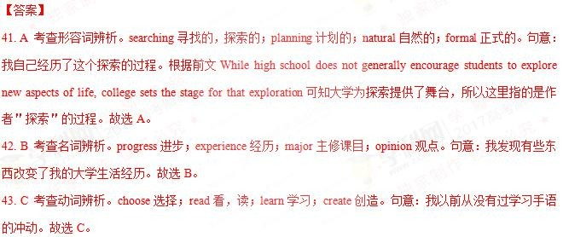

D 考查形容词辨析。official 官方的；foreign 外国的；body 肢体的；spoken 口语的。根据前文 My entire family is hearing, and so are all my friends.可知作者的家人及朋友都可以听得到，因此作者认为在平时的交流中，口语就足 够了。spoken language 口语。故选 D。

45. A 考查名词辨析。love 热爱；concern 关心，顾虑；goal 目标；request 请求。句意：我没想过我会发现自己对 美式手语的热爱。前文中 I never felt an urge to 43 any sign language before 表明作者以前从未想过学习手 语，而根据后文内容可知作者非常喜欢手语。故选 A。

46. C 考查名词辨析。meeting 会议；trip 旅行；story 故事；task 任务。句意：故事发生在我上大学的第一周 分 析语境可知在这里作者开始讲述在大学学习手语的事情，故选 C。

47. B 考查动词辨析。record 记录；perform 表现，表演；recite 背诵；discuss 讨论。句意：我观看他们在 ASL 俱 乐部 表演 一首歌 的翻 译 。分析 语境 可知 ASL 俱乐 部是 手语俱 乐部 ，应该 是在 用手语 表演一 首歌 。故

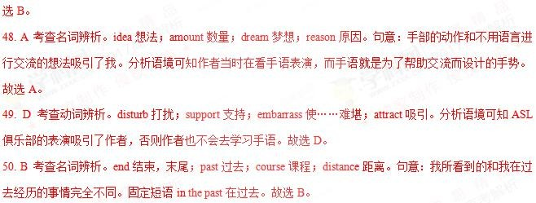

51. D 考查动词辨析。show 展示；act 行动；say 说；want 想要。句意：这种新奇的感觉使我想了解更多。分析

语境可知作者被手语吸引，想要进一步了解，所以也有了后文中的参加手语俱乐部的会议，上手语课的经历。故 选 D。

52. B 考查动词辨析。exercise 锻炼；explore 探索；express 表达；explain 解释。句意：在那之后，我感觉到想要 探索更多关于手语的东西，我参加了 ASL 俱乐部的一次会议。故选 B。

53. C 考查动词辨析。print 打印；write 写；sign 签名，打手语；count 数。句意：那天我只学会了打字母表的手 语。分析语境可知作者第一次参加手语俱乐部的会议，学会的应该是最基本的打字母表的手语。当然，打印字母 表、在字母表上签名、数字母表和学习手语都没有联系。故选 C。

54. A 考查形容词辨析。slow 缓慢的；steady 平稳的；normal 正常的；obvious 明显的。句意：我并没有因为缓慢 的进步而沮丧，相反我很兴奋。因为作者只学会了打字母表的手语，所以进步是很慢的。故选 A。

55. C 考查动词辨析。chair 主持，使……入座；sponsor 赞助；attend 参加；organize 组织。句意：我下定决心参 加俱乐部所有的会议去学习我能学习的一切。attend meeting 参加会议。故选 C。

56. D 考查动词辨析。miss 错过，想念；pass 通过；give up 放弃；register for 报名注册。句意：接下来的一个学 期，我报名上了一个手语班。故选 D。

57. A 考查动词辨析。prohibit 禁止；welcome 欢迎；ignore 忽视；repeat 重复。句意：教授的耳朵听不见，任何 口语交流都是禁止的。根据后文 if there had been any talking 可知在课堂上没有口语交流。故选 A。

58. C 考查副词辨析。lastly 最后，终于；thus 因此，如此；instead 反而；however 然而。句意：反而，如果当时 有口语交流，那只会造成我们学的手语更少。根据前文 I soon realized that the silence was not unpleasant.可知作者 很快意识到安静并不是令人不愉快的，反而有口语交流会影响手语的学习。故选 C。

59. B 考查动词辨析。require 要求；cause 造成；allow 允许；expect 期待。句意：如果当时有口语交流，那只会 造成我们学的手语更少。故选 B。

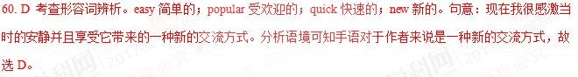

**2017** 全国卷 **2**

【解析】

【整体分析】本文是一篇记叙文，主要讲了作者的一个学生 Freddy 既有趣又有同情心，作者在 Freddy 高中毕业 前送给他一件衬衫，上面写着告诫他“动词”在人生中的重要性，而他在毕业后也保持着乐于助人的品质，但不幸 的是 Freddy 在若干年后去世了，而那件衬衫也回到了作者的手中，作者以及他的学生们都从 Freddy 身上学到了 一些宝贵的品质。

41.B

考查动词词义辨析，A. built 建造， B. entered 进入， C. decorated 装饰， D. ran 跑步。每天，27 个孩子都会“进 入”“思想实验室”，故选 B。

42.A

考查名词词义辨析，A. name 名字， B. rule 规则，C. brand 品牌， D. plan 计划。 “思想实验室”这个“名字”是 同学们投票得来的，故选 A。

43.D

考查形容词词义辨析，A. small 小的，B. dark 黑的， C. strange 奇怪的， D. dull 无聊的，由后文可知，同学们 是因为“104 班级”这个名字太“无聊”才把名字改为“思想实验室”的，故选 D。

44.B

考查名词词义辨析，A. scholar 学者， B. student 学生， C. citizen 市民， D. worker 工人，通读全文可知 Freddy

是作者的一名“学生”，故选 B。

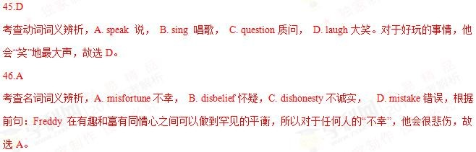

47.

D

考查动词词义辨析，A. changed 改变， B. approached 接近， C. returned 返回，D. ended 结束。在学期“结束”

之前，我…… 故选 D。

48.B

考查名词词义辨析，A.lesson 课，教训， B.gift 礼物， C.report 报告，D.message 信息，根据后文可知作者送给

Freddy 一件衬衫，即一个特殊的礼物，故选 B。

49.A

考查名词词义辨析，A.friends 朋友，B.Awards 奖， C.Masters 主人，D.Tasks 任务。衬衫上写着“动词是你的朋 友”，故选 A。

50.C

考查形容词词义辨析，A.simple 简单的，B.unique 独特的， C. fun 有趣的，D.clever 聪明的。 “尽管动词也许看 起来很无聊，但人们的一生当中做的大部分有趣之事都将是动词”，“无聊”与“有趣”相对，故选 C。

51.D

考查名词词义辨析，A.assessments 评估，B. comments 评论， C.instructions 指导， D.updates 更新。我遇到过 以前的学生，他们常常会提供一些老同学的“最新情况”，故选 D。

52.A

考查名词词义辨析，A.graduation 毕业， B. retirement 退休，C.separation 分离，D.resignation 辞职。在 Freddy

高中毕业后，做了好几份工作，故选 A。

53.C

考查形容词词义辨析，A.daring 勇敢的， B.modest 谦虚的，C.caring 贴心的， D.smart 聪明的。他让无家可归的 人睡在了他的卡车上，可知他仍然是很爱关照人的，贴心的，故选 C。

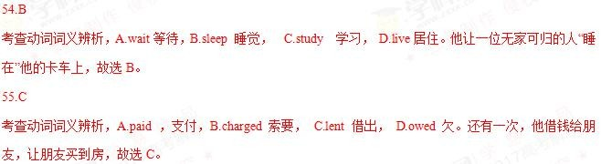

56.

D

考查动词词义辨析，A.observing 观察， B.preparing 准备，C. designing 设计， D.conducting 组织，实施，执 行。我正在班级里组织一个专题研讨会的时候，突然有人敲门，故选 D。

57.C

考查动词词义辨析，A.regretted 后悔，遗憾， B.avoided 避免，C.excused 原谅，宽恕， D.ignored 忽视。因为当

时正在上课，所以这名女子为自己的打断行为要求得到原谅，故选 C。

58.A

考查动词词义辨析，A.opened 打开，B.packed 打包， C.gave 给予， D.held 握住。我停止教学，打开信封，故选

A。

59.C

考查名词词义辨析，A.picture 图片， B.bill 账单，C.note 纸条，便笺， D.diary 日记，根据后文的描述，可知 衬衫上是一个便笺，上面写着…… 故选 C。

60.B

考查动词词义辨析，A.chose 选择， B.took 拿走， C.expected 期待， D.borrowed 借入。尽管 Freddy 离开了 我们，我们从他的身上也带走了一些东西，故选 B。

**2017** 全国卷 **3**

41. C 考查名词。A. benefits 利益；B. deposits 押金；C. restrictions 限制；D. examinations 考试。根据后句内容 You must be named Elizabeth Gallagher and have a Canadian 42 可知申请免费环球旅行是有条件限制的，需要是名 叫 Elizabeth Gallagher、有加拿大护照的女子。

42. B 考查名词。A. origin 来源；B. passport 护照；C. accent 口音；D. friend 朋友。根据第三段中的 including thirty from actual Elizabeth Gallaghers with the 50 passports 可知，申请人需要有加拿大的护照。故选 B。

43. D 考查名词。A. holiday 假期；B. marriage 婚姻；C. dream 梦想；D. relationship 关系。根据下文 Jordan Axani

转让机票可知他和女朋友关系结束了。

44. A 考查动词短语。A. go to waste 浪费；B. come to mind 想到；C. go on sale 开始销售；D. come into effect 开 始生效。根据下文＂I just want to see the ticket go to good use and for someone to 48 a lot of joy＂可知他之所以 想把票赠送给同名的人，目的是不想浪费掉机票。故选 A。

45. A 考查名词。A. policy 政策；B. order 命令；C. payment 付款；D. schedule 计划，时间表。机票都是实名制， 而且不可以转让，根据常识和语境可知这是一种政策。故选 A。

46. B 考查动词。A. applying 申请；B. booking 预订；C. checking 核实；D. bargaining 讨价还价。虽然机票不可转 让，但是在预订的时候不需要护照的具体信息，因此在预订后这张机票可以给姓名相同的人使用。故选 B。

51.

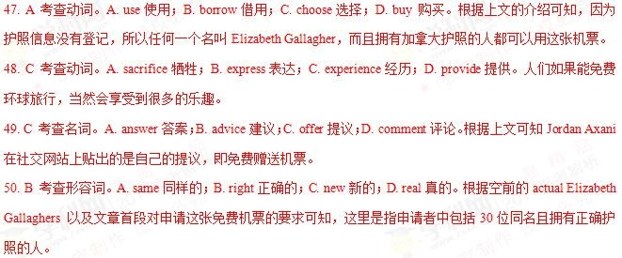

A 考查形容词。A. interesting 有趣的；B. annoying 令人恼火的；C. satisfying 令人满意的；D. convincing 令人信 服的。根据空后的内容可知有数百人想改名字，这当然是一件很有趣的事情。

52. D 考查动词。A. writing 写；B. giving 给；C. lending 借出；D. changing 改变。根据上文可知申请的要求是需 要和 Jordan Axani 前女友同名，所以有人甚至想改名字。

53. D 考查名词。A. touch 触动；B. question 问题；C. date 日期；D. control 控制。根据后句内容可知，世界上的

很多人都知道这件事，如果允许人们改名字的话，那么事情就会无法控制。

54. C 考查动词。A. admiring 羡慕；B. advertising 广告；C. sharing 分享；D. doubting 怀疑。根据上文可知 Jordan

Axani 收到了数千封邮件，所以很多人都分享他们的旅行故事。

55. B 考查动词。A. leaving 离开；B. looking for 寻找；C. losing 失去；D. dealing with 对付。根据文章首段的首 句可知 Jordan Axani 是免费送给别人他多余的票，而不求回报。

56. D 考查形容词。A. single 单一的；B. strange 奇怪的；C. regular 定期的；D. extra 额外的。根据第二段可知 Jordan

Axani 在和女朋友分手后，女朋友的机票就是多余出来的了。

57. B 考查动词。A. return 回去；B. take 拿走；C. reserve 保留；D. hide 隐藏。根据空后内容 and travel on her own

可知，申请到票的人可以和他一起旅行，也可以拿着票自己去旅行。

58. C 考查名词。A. interview 采访；B. program 项目；C. trip 旅行；D. meeting 会面。根据第三段末句 their stories of travel 可知，Jordan Axani 是在赠送环球旅行的飞机票。

59. A 考查动词。A. ending 结尾；B. calling 打电话；C. repeating 重复；D. staying 停留。根据句意可知旅行是

December 21 从纽约出发，途经米兰、布拉格等多个城市，最后到达多伦多，结束旅行。

60. D 考查形容词。A. honored 感到光荣的；B. lovely 可爱的；C. intelligent 聪明的；D. lucky 幸运的。文章介绍 了 Jordan Axani 免费赠送环球旅行的机票的故事，所以能选上的人是幸运的人。

**2017** 北京卷

【答案】

36-40 BDCAD 41-45 BACDC 46-50AABCB 51-55ADBCD

【解析】

【语篇解读】本文讲述 Hannah Taylor 通过自己的努力来建立公益组织筹集资金帮助那些无家可归忍饥挨饿的人。

3

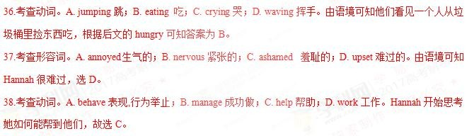

9.考查动词。A. pushing 推；B. carrying 拿；C. buying 买；D. holding 握。购物车肯定是推着的，故选 A。

40.考查名词。A. goods 货物；B. bottles 瓶子；C. foods 食物；D. bags 包。车上堆满了包，选 D。

41.考查形容词。A. excited 激动的；B. determined 下决心的；C. energetic 精力充沛的；D. grateful 感激的。 她更加下定决心做些事帮助这些人，故选 B。

42.考查连词。A. since 自从；B. unless 除非；C. although 尽管；D. as 因为。此处是指自从他们第一次看到 无家可归的人，选 A。

43.考查动词。A. sound 听；B. get 获得；C. feel 感觉；D. look 看。她就不会和以前一样感觉那么糟糕了，故选 C。

44.考查动词。A. exchange 交换；B. leave 离开；C. keep 保持；D. spread 传播。她希望她的希望和意识的信 息能够传播开来。故选 D。

45.考查动词。由语境可知她希望信息能够传播开来。spread 传播。

46.考查动词。A. contribute 贡献，捐献；B. lead 领导；C. apply 申请，应用；D. agree 同意。她试图劝说那 些领导能为这个事业做出奉献，选 A。

47.考查名词。A. campaign 运动；B. trip 旅行；C. procedure 过程；D. trial 实验。此处指又一项运动，故选 A。

48.考查形容词。A. elderly 年纪大的；B. hungry 饥饿的；C. lonely 孤独的；D. sick 生病的。此处是指为那 些饥饿的人和无家可归的人，选 B。

49.考查形容词。A. aware 意识的；B. afraid 害怕的；C. proud 骄傲的；D. sure 肯定的。此处是指 Hannah 非

常骄傲的东西，故选 C。

50.考查动词。A. going 去；B. sleeping 睡； C. traveling 旅行；D. playing 玩。当天冷到在室外睡觉就意味 着死的时候，故选 B。

51.考查名词。A. praises 赞美；B. invitations 邀请；C. replies 回复；D. appointments 约会。她收到了很多的 赞美。因为下文有这方面的举例，答案为 A。

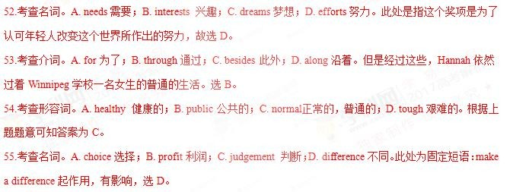

**2017** 天津

16.【答案】C

【解析】



考点：考查动词辨析。

17.【答案】A

【解析】

试题分析：根据 At my heaviest I weighed 370 pounds. 和上文 Worried about my health 可知本句表示：我尝试了不 同种类的饮食，但都没有起作用。A. 饮食；B. 饮料；C. 水果；D. 菜。根据句意，故选 A。 考点：考查名词辨析。

18.【答案】D

【解析】

试题分析：根据上文 I tried many different kinds of 17 but nothing worked.可知下文是：我开始觉得我对自己 的体重无能为力。A. 身高；B. 能力；C. 聪明；D. 体重。根据句意，故选 D。

考点：考查名词辨析。

19.【答案】C

【解析】



考点：考查副词辨析。

20.【答案】B

【解析】

试题分析：根据前句可知下文是：我不想我的余生带着这些额外的体重。A.理想的；B. 额外的；C.正常的；D. 低 的。故选 B。

考点：考查形容词辨析。

21.【答案】A

【解析】

试题分析：根据宾语 a seminar(一个研讨班)可知，我参加了一个研讨班。A. 参加；B. 组织；C. 推荐；D. 提到。

故选 A。 考点：考查动词辨析。

22.【答案】B

【解析】

试题分析：根据下文 she had not only lost 125 pounds, but also raised $25,000 for homeless children.可知，研讨会的 一个领导和我分享了她的成功故事。A.民间；B. 成功；C. 探险；D. 学。故选 B。

考点：考查名词辨析。

23.【答案】C

【解析】

试题分析：根据上文的成功故事和下文 I created the As We Heal(痊愈), the World Heals 24 .可知，我被她的 故事所影响。A. 感到惊讶；B. 感到高兴；C. 被影响；D. 被打扰。故选 C。

考点：考查非谓语。

24.【答案】A

【解析】

试题分析：根据下文 My goal was ...可知，我创建了这个 As We Heal(痊愈), the World Heals 项目。A. 工程，项目；

B. 生意；C. 系统；D. 风俗习惯。故选 A。下文 30 空后的句子中的 project 是提示。 考点：考查名词辨析。

25.【答案】D

【解析】

试题分析：根据上文 raise $50,000 可知，此处表示“为了支持三十年前为了结束饥饿而创办的一项活动”。A. 为 了寻找；B.需要；C.代替；D. 为了支持。故选 D。

考点：考查介词短语辨析。

26.【答案】D

【解析】

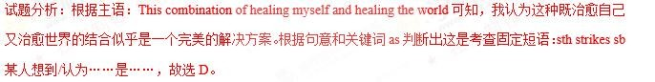

考点：考查动词辨析。

27.【答案】A

【解析】

试题分析：根据主句：I was filled with the fear...(我充满了恐惧……)可知此处是“当我开始我的个人体重项目时”。

A. 当……的时候；B.直到；C.如果；D. 除非。故选 A。 考点：考查连词辨析。

28.【答案】B

【解析】

试题分析：根据上文 fear 和下文 he same difficulties that beat me before 可知，我充满了恐惧，害怕遇到以前打败 我的同样的困难。A. 克服，战胜；B. 遇到；C. 寻找；D. 把……放到一边。故选 B。 考点：考查动词短语辨析。

29.【答案】D

【解析】

试题分析：根据上文 I was filled with the fear that ...可知，尽管恐惧围绕在我的脑海。A.兴奋；B. 快乐，高兴；C.

生气；D. 恐惧。故选 D。 考点：考查名词辨析。

30.【答案】C

【解析】

试题分析：有迹象表明我正走向正确的道路。A.排；B. 大厅；C. 路；D. 街道。故选 C。 考点：考查名词辨析。

31.【答案】B

【解析】

试题分析：根据上文 It worked perfectly 可知，捐款从几百人那里涌入。break in 闯入；flood in 大量涌入；jump in 跳进；step in 步入。故选 B。

考点：考查动词辨析。

32.【答案】D

【解析】

试题分析：根据上文 hired a fitness coach 可知，我开始每餐吃少量且健康的食物。A. 重的；B. 满的；C. 贵的；

D. 健康的。故选 D。

考点：考查形容词辨析。

33.【答案】A

【解析】

试题分析：根据 exercise 可知，我的募集资金的核心也给了我新的激励，让我定期锻炼。A. 定期地；B.无限度地；

C. 突然地；D. 随意地。故选 A。 考点：考查副词辨析。

34.【答案】B

【解析】



考点：考查动词辨析。

35.【答案】C

【解析】 试题分析：根据上文的成功可以判断出句意为“我感觉到我被给予了第二次生命来做有意义的大事”。A. 有压力 的；B. 疼痛的；C. 有意义的；D. 和平的。故选 C。

考点：考查形容词辨析。

**2017** 江苏

36. D【解析】考查动词。根据＂with their heavy instrument cases＂可知，每天上学的时候，Gabriel 总是同情地看 着背着沉重乐器的同学们艰难地穿梭于校园中，struggle 努力，艰难地行进，斗争，符合语境。

37. D【解析】考查动词短语。根据＂ 37 at school for practice hours 38 anyone else＂可知， 学习音乐的同学需要比不学音乐的早到学校几个小时，为了练习弹奏乐器。turn up 在＂出现＂，符合语境。

38. A【解析】考查介词。＂anyone else＂指不学音乐的学生，学习音乐的要比规定的到校时间早到几个小时，before anyone else had to be there 比规定的到校时间早几个小时。这也是 Gabriel 不想学习音乐的原因之一。

39. C【解析】考查动词。根据＂as he hated getting to school extra early＂可知，Gabriel 讨厌过早到校，因此他对 自己发誓＂不学＂音乐，A 背叛；B 接受；C 避免，避开；D 欣赏。故选 C。

40. B【解析】考查连词。此处是说，Gabriel 在一次音乐课上意外发现自己很喜欢音乐，此处所表达的含义与上 一段是转折关系，故选 B。

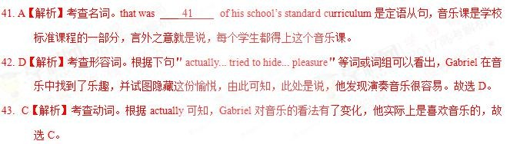

44. B 【解析】考查形容词。Gabriel 不想让音乐老师看到自己表露出来的很明显的喜悦之情，transparent 指(谎言、 借口)易看穿的；obvious 明显的，显然的；false 假的；similar 相似的。故选 B。

45. D【解析】考查动词。音乐老师在教室里来回走动，听到 Gabriel 弹奏乐器的声音，就走过来聆听。run 跑；jog

慢跑；jump 跳；wander 徘徊，游荡。wander over 漫步。

46. B【解析】考查连词。前句是说他弹得不是特别好，后句是说，老师告诉他他有良好的辨音能力，并且建议他 去音乐商店选适合自己的乐器。前后句间为转折关系。

47. A【解析】考查名词。老师认为 Gabriel 有着很好辨音能力，并建议他去挑一件称心的乐器。ear 辨音力，灵敏 的听力；taste 鉴赏力，欣赏力，指对作品的欣赏能力。由于 Gabriel 没有经过专业的训练，不能说他有很 好的音乐鉴赏能力，taste 不符合语境。

48. C【解析】考查动词短语。occur to sb.某人突然想起；take to 开始喜欢；appeal to 有吸引力，引起兴趣；hold to

抓住。老师让 Gabriel 找一件自己喜欢的乐器。

49. B【解析】考查名词。Gabriel 准备试一下大提琴，给大提琴一次机会，即尝试演奏一下大提琴。change 改变；

chance 机会；mission 任务；function 功能。故选 B。

50. C【解析】考查副词。根据 But 可知，前后是转折关系，下句说 Gabriel 发现自己很喜欢大提琴，说明前一句 是说他只是随便拉一下。seriously 认真地；proudly 骄傲地；casually 随便地；naturally 自然地。故选 C。

51. A【解析】考查动词。根据＂so that within a couple of months he was playing reasonably well＂可知，花了几个 月的时间练习之后，Gabriel 的大提琴已经拉得非常好了。be committed to sth/doing sth 致力于。故选 A。

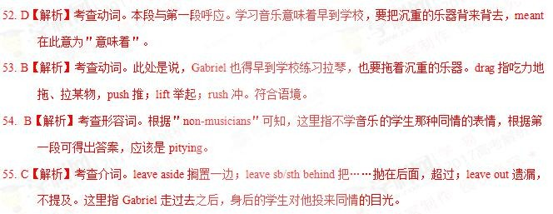

**2017** 浙江

【解析】本文是一篇记叙文。主要讲述了 Alia Baker 是伊拉克图书馆的馆长，当伊拉克爆发战争时，Alia Baker 害怕战争会破坏图书，于是向政府求助，在遭到拒绝后，Alia Baker 自己用双手一点点把书搬出来，最后在家人、 朋友和邻居的帮助下，Alia Baker 将书转移到了安全的地方。

a restaurant 46 to hide some books”根据语境分析，Anis 同意把书藏在她的饭店里面。故选 D。

3

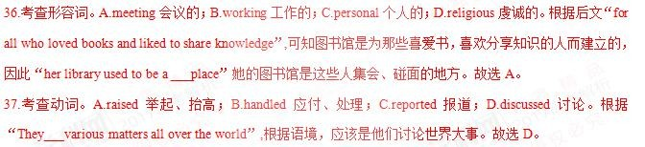

8.考查形容词。A.worried 担心；B.angry 生气；C.doubtful 怀疑的；D.curious 好奇的。根据后文“So Alia took matters into her own hands”，Alia 用双手搬书，可知“Alia was that the fires of war would destroy the books”,Alia 担心 战火会破坏书。故选 A。

39.考查形容词。A.practical 实践的；B.precious 珍贵的；C.reliable 可靠的；D.expensive 昂贵的。根据后文“which are more to her than mountains of gold”,由 more 可知，是将书与金山作比较，可见书的珍贵性。故选 B。

40.考查副词。A.then 然后；B.still 仍然；C.even 甚至；D.rather 稍微。根据“a book on the history of Iraq that is seven hundred years old ”, 这本关于伊拉克历史的书已经有了七百年的历史，因此是比较宝贵的，与前面“new books,ancient books”是一种层次上的上升与递进关系。故选 C。

41.考查名词。A.permission 许可；B.confirmation 确认；C.explanation 解释；D.information 信息。根据“She had asked the government for to move the books to a place”,可知她想获得政府的许可，将书转移到安全的地方。故选 A。

42.考查形容词。A.large 大的；B.public 公共的；C.distant 遥远的；D.safe 安全的。根据“She had asked the government for permission to move the books to a place”,她想获得政府的许可，将书转移到（ ）的地方。故选 D。

43.考查副词。A.Fortunately 幸运地；B.Surprisingly 惊奇地；C.Seriously 严重地；D.Secretly 秘密地。根据“she brought books home every night”,可知她是在秘密地转移书籍。故选 D。

44.考查动词。A. Starting 开始；B.parking 停车；C.filling 装满；D.testing 测试。根据“ her car late after work”,

可知，在工作之后，她的车都被书装满的。故选 C。

45.考查动词。A.stop 停止；B.help 帮助；C.warn 警告；D.rescue 营救。根据后文“Anis who owned a restaurant 46 to hide some books.”可知，她的朋友们都过来帮她转移书。故选 B。

46.考查动词。A. intended 打算；B. pretended 假装；C. happened 发生；D. agreed 同意。根据“Anis who owned

5

0.考查动词。A. approached 接近；B. erupted 爆发；C. continued D. ended 结束。由后文 “Then nine days laters, a fire burned the 51 to the ground.”可知，战争仍在继续。故选 C。

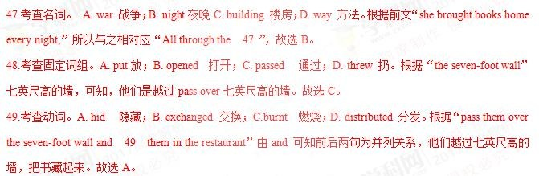

51.考查名词。A. restaurant 饭店；B. library 图书馆；C. city 城市；D. wall 墙壁。根据后文“Now Alia waited for the war to end and 55 peace and a new library”可知原来的图书馆已经损毁，所以“a fire burned the 51 to the ground.”战火蔓延到了图书馆。故选 B。

52.考查名词。A. neighbours 邻居；B. soldiers 士兵；C. friends 朋友；D. customers 顾客。“the bombing stopped and the 52 lef”，and 连接两个并列句，轰炸停止，与之相对应的是，士兵离开了。故选 B。

53.考查动词。A. sold 卖；B. read 阅读；C. saved 救；D. moved 移动。根据“So she hired a truck to bring all the books to the houses of friends in the suburbs(郊区)”，可知，她决定要再次移动书。故选 D。

54.考查形容词。A. occupied 占据；B. bombed 轰炸；C. quiet 安静的；D. busy 忙的。“the bombing stopped and the soldiers left”根据语境，战争刚结束，城市应该很安静。

55.考查动词词组。A. dreamed of 梦想；B. believed in 相信；C. cared about 关心；D. looked for 寻找。根 据“Now Alia waited for the war to end and 55 peace and a new library.”可知，她期望和平的到来。故选 A。

**2016** 全国卷 **1**

【答案】

41.C 42.D 43.C 44.B 45.A 46.B 47.A 48.D 49.C 50.A

51.D 52.B 53.D 54.A 55.C 56.B 57.B 58.D 59.A 60.C

【解析】

试题分析：本文是一篇记叙文主要介绍了司机 Larry 在路上遇到着火的汽车，积极救人的故事。

41.C 考查动词辨析。根据下文中 Larry pulled over…可知他沿着公路行驶。Travel“行进”，故选 C。

42.D 考查名词辨析。根据首句 Larry works with Transport Drivers, Inc.可知他是司机，由此推断他应该是在给客户 送完货后回去的路上。

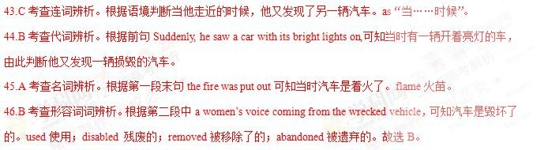

47.A 考查动词辨析。根据后句可知他下车灭火。get hold of 拿起；prepare 准备；take charge of 负责；control 控制。 故选 A

48.D 考查动词辨析。根据 and told Larry he had _49 an emergency call 可知，那个司机走了过来和 Larry 说话。

come down 下来； come through 经历；come in 进来；come over 走过来。故选 D。

49.C 考查动词辨析。根据下文可知这个司机打了电话报警。make a call 打电话。 故选 C。

50.A 考查副词辨析。根据语境判断他们听到车内有人发出的声音。then 那时；again 再次；finally 终于；even 甚 至。故选 A。

51.D 考查动词辨析。根据上文可知汽车着火了，情况很危险，由此推断 Larry 离汽车远，由此判断走近，才看到 车内的那位女士。

52.B 考查形容词辨析。根据本段末句 she should not move 可知，Larry 让这名女士不要动。quiet 安静的；still 不 动的；away 远离的；calm 沉着的。故选 B。

53.D 考查连词辨析。根据后句可以推断这位受困的女士想从汽车里出来，而 Larry 不让她动，怕她伤到脖子，这

两句话之间是转折关系。

54.A 考查动词辨析。根据后句内容判断这位妇女害怕汽车会爆炸。explore 爆炸；slip away 溜走；fall apart 崩溃；

crash 坠毁，摔碎。故选 A 。

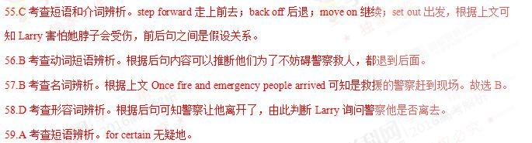

60.C 考查名词辨析。patience 耐心；skill 技能；effort 努力；promise 承诺。 故选 C。根据上文可知 Larry 努力挽 救了别人的性命。选 C。

考点：故事类短文阅读

**2016** 全国 **2**

【答案】21. D 22. A 23. B 24. C 25. A26. D 27. A 28. A 29. C 30. D

31. A 32. B 33. B 34. C 35. C36. D 37. D 38. B 39. C 40. B

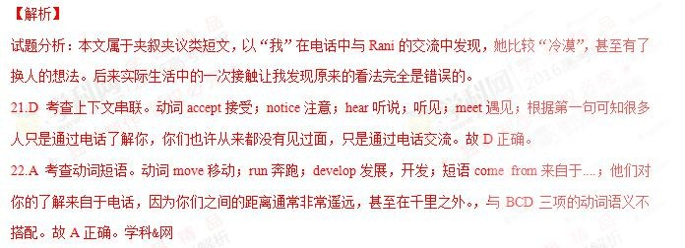

23.B 考查上下文串联。虽然你们之间的距离很远，但是他们只要通过你的声音，就可以了解你。上下文之间是 转折关系，所以使用副词 yet 串联前后语义。故 B 正确。

24.C 考查副词辨析。副词 rather 相当地；also 也；just 只是；already 已经；本句使用 just 表示强调，别人只要通 过声音就可以了解你。故 C 正确。

25.A 考查上下文串联。根据 26 空后“only by phone”可知本文介绍的是电话，人们可以通过电话了解你。故 A

正确。

26.D 考查上下文串联。形容词 direct 直接的；useful 有用的；easy 容易的；accurate 准确的；本空前的 but 说明 上下文之间是转折关系，电话虽然很强大，但是也并不是很准确。与 ABC 三项语义不搭配。故 D 正确。

27.A 考查介词辨析。介词 in person 亲自，by myself 靠自己；in public 当众；on purpose 故意地；A 项与空前的

faceless 形成呼应，Rain 是代理人，但是我们从来没有碰过面。故 A 正确。

28.A 考查上下文串联。空前的 cold voice 可知 Rani 在电话里的声音很冷漠，和让我很不高兴，甚至想过要另外 找一个代理人。说明我对他的声音很反感。故 A 正确。

29.C 考查上下文串联。动词 promote 提拔；train 训练；find 寻找，找到；know 知道；正是因为 Rani 的声音让我 很不舒服，所以我曾经想过另外找代理人取代他。故 C 正确。

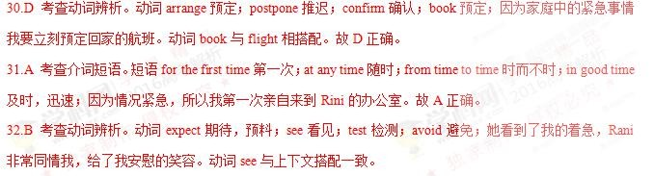

33.B 考查形容词辨析。形容词 shy 害羞的；comforting 安慰的；familiar 熟悉的；forced 被迫的；她看到我很着 急，笑着安慰我。故 B 正确。

34.C 考查上下文串联。根据 30 空可知我要预定回家的航班的机票，本句中 Rani 很快帮我把机票打印出来。故 C

正确。

35.C 考查上下文串联。副词 hopefully 充满希望地；disappointedly 感到失望地；gratefully 感激地；regretfully 遗 憾地；对方如此迅速地帮我把机票打印出来，而且一直面带微笑，这让我心存感激。故 C 项正确。

36.D 考查上下文串联。形容词 careful 细心的；serious 严肃的，认真的；nervous 紧张的；pleasant 令人愉快的； 现实生活中的 Rani 富有同情心，待人热情大方。是一个令人愉快的相处对象。所以当我转身时，看见的是与电 话中完全不一样的 Rani。故 D 项正确。

37.D 考查上下文串联。现实生活中的她是如此的体贴大方，而我之前却认为她很冷漠，甚至有了要另找代理的 想法，我真是无话可说。说明电话中得到的印象有时很不准确。故 D 项正确。

38.B 考查上下文串联。在文章 28 空前“cold”以及前句“...she was cold”之前我因为 Rani 很冷漠，但却没有想 到实际生活中的 Rani 是如此的美好善良。故 B 项正确。

39.C 考查名词辨析。名词 forgiveness 谅解；eagerness 急切；friendliness 友好；skillfulness 熟练；从 52-54 空内 容可知 Rani 对我非常友好善良，并没有电话中的那种冷漠的感觉。故 C 项正确。

40.B 考查名词辨析。名词 explanation 解释；attitude 态度；concept 概念；behavior 行为；Rani 的善良友好的态度 并没有从电话线中传递过去。B 项指 Rani 接待我的友好的态度。故 B 项正确。

考点：考查夹叙夹议类阅读

**2016** 全国 **3**

【答案】

21. B 22. D 23. A 24. C 25. A 26. B 27. D 28. C 29. C 30. A 31. B 32. C 33. B 34. D

35. A 36. C 37. D 38. A 39. D 40. B

【解析】

试题分析：文章讲述了一个与足球有关的故事。作者想成为球队里最棒的球员，并向最优秀的球员 Miller 看齐。为了实现梦想，作 者刻苦训练，在 Miller 受伤之后，作者脱颖而出，成为最有价值的球员。作者的表现也得到了 Miller 认可。

21. B 考查动词短语辨析。A. cheering for 为……欢呼；B. be ating out 打败；C. relying on 依靠；D. staying with 和……待在一起。根据＂become the star on our football team＂可知，要想成为球队里的明星，就要打败最优 秀的球员，故选 B。



22. D 考查名词辨析。A.coach 教练；B. student 学生；C. teacher 教师；D. player 选手，球员。全校最好的球 员是 Miller King，故选 D。

23. A 考查名词辨析。A.practice 练习；B. show 演出，表现，节目；C. comfort 安慰；D. pleasure 乐趣。作者 随身带着足球是为了练习，故选 A。

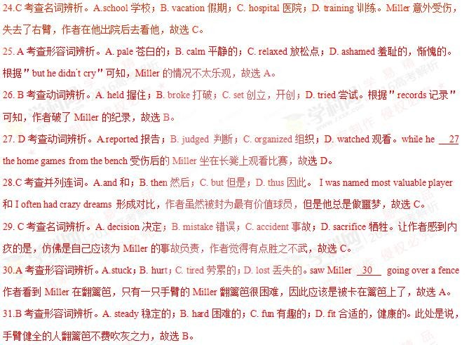

32. C 考查名词辨析。A.praise 表扬；B. advice 建议；C. assistance 帮助；D. apology 道歉。作者认为 Miller

最不愿接受作者的帮助，the last 最不可能的，故选 C。

33. B 考查动词辨析。A.let 让；B. helped 帮助；C. had 有，使；D. noticed 注意到。根据＂he accepted＂可知，

Miller 接受了作者的帮助，故选 B。

34.D 考查形容词辨析。A. dropped；B. ready 准备好的；C. trapped 被困住的；D. safe 安全的。作者和 Miller

两人成功翻过篱笆，故选 D。

35.A 考查副词辨析。A.fine 够好，可接受；B. wrong 错误地；C. quickly 迅速；D. normally 正常。Miller 认 为作者表现得很好，故选 A。

36.C 考查代词辨析。A. us 我们；B. yourself 你自己； C. me 我；D. them 他们。Miller 感谢作者填补了他的 空缺，故选 C。

考

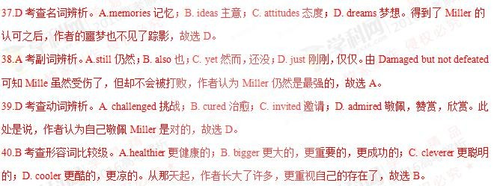

点：生活故事类短文阅读

**2016** 北京卷

【答案】

36. A 37.B 38.D 39.C 40.B

41.C 42.D 43.A 44.B 45.A

46.C 47.D 48.C 49.D 50.C

51.A 52.B 53.A 54.D 55.B

【解析】

试题分析：文章讲述了一个人们接力运送药物来救患病儿童的感人故事。1925 年 1 月份的阿拉斯加北部极其寒 冷，由于大雪，诺姆小镇与外界隔绝了。雪上加霜的是，那里的孩子患上了一种致命的传染病——白喉。为了拯 救孩子们，人们接力运送药品到诺姆。最终，人们通过狗拉的雪橇把药物送到了诺姆。

4

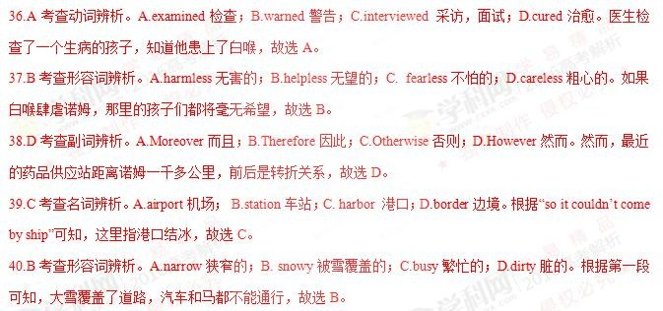

1.C 考查介词辨析。A. From 从，自；B. On 在……上面；C. By 通过，在……之前；D. After 在……之后。“by+

时间”与完成时连用，后跟过去的时间，用过去完成时；跟将来的时间，用将来完成时，故选 C。

42.D 考查形容词辨析。A. tired 劳累的；B. upset 难过的；C. pale 苍白的；D. sick 生病的。四个孩子相继去世， 还有 20 几个患病，故选 D。

43.A 考查名词辨析。A. plan 计划；B. excuse 借口；C. message 信息；D. topic 话题。当地的官员想到了一个计划， 故选 A。

44.B 考查名词辨析。A. air 空气；B. rail 栏杆，铁轨；C. sea 海洋；D. road 道路。根据下一段“from the train at Nenana”

可知，药物被用火车运到 Nenana，故选 B。

45.A 考查动词辨析。A. carry 运送，携带；B. return 返回，归还；C. mail 邮寄；D. give 给。然后再由乘坐狗拉的 雪橇的人把药物接力送到诺姆，故选 A。

46.C 考查时间状语从句。A. Though 虽然；B. Since 因为，自从；C. When 当；D. If 如果。当他把药物交给下一 个人时，他的脸已经被冻得乌青，故选 C。

47.D 考查动词辨析。A. enter 进入；B. move 移动；C. visit 拜访；D. cross 穿过。根据“Norton Sound was covered with ice”可知，Norton Sound 是一片冰冻的水域，Seppala 必须穿过这片水域，故选 D。

48.C 考查形容词辨析。A. shameful 惭愧的；B. boring 令人厌烦的；C. dangerous 危险的；D. foolish 愚蠢的。根据

“which could sometimes break up without warning”可知，这是旅途最难的一部分，故选 C。

49.D 考查动词辨析。A. escape 逃跑；B. bleed 流血；C. swim 游泳；D. die 死亡。如果掉进寒冷的水中，Seppala

会被冻死，诺姆的病童们也会死，故选 D。

考 点：人物故事类短文阅读

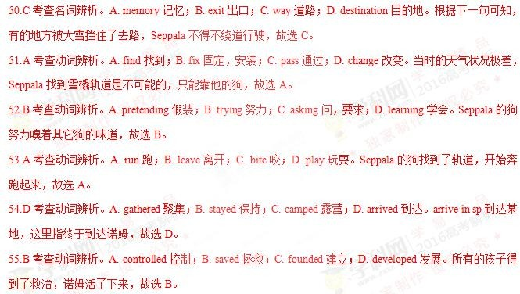

**2016** 天津

【语篇解读】这是一篇记叙文。作者 讲述自己十岁的女儿在童年遭受病痛之苦，在接受治疗之后好转。之后决 心做一个游泳选手，虽然身体不适，还是坚持训练，虽然经常是比赛的最后一名，但是一直不放弃。最后教练的 一番话给予 Cathy 最大的奖励和肯定。



16.【答案】D

考 点：考查副词辨析。

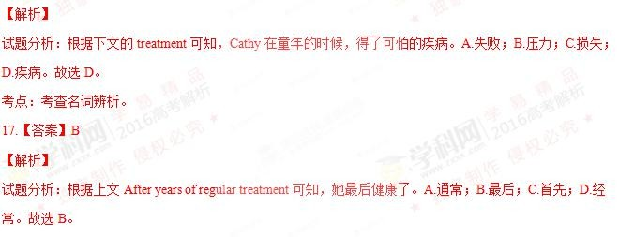

18.【答案】C

【解析】

试题分析：根据上文 a dream came into her sweet little head 可知，她想参加我们当地的游泳队。A.提高；B.

训练；C.参加；D.联系。故选 C。 考点：考查动词辨析。

19.【答案】D

【解析】

试题分析：根据上文 She practiced hard 可知，她最后做到了。A.增加；B.发现；C.创造；D.使得。make it

做到，成功。故选 D。 考点：考查动词辨析和固定搭配。

20.【答案】A

【解析】

试题分析：根据下文 was a tough start 可知，然而，游泳队的训练是个艰难的开始。A.然而；B.因此；C.否

则；D.代替。故选 A。

考点：考查副词辨析。

21.【答案】B

【解析】

试题分析：根据上文 she coughed and choked 可知，她咳嗽，窒息，在前几个星期几乎不能生存。A.使用； B.

生存； C. 拯救；节约；D.浪费。故选 B。 考点：考查动词辨析。

22.【答案】A

考 点：考查形容词辨析。

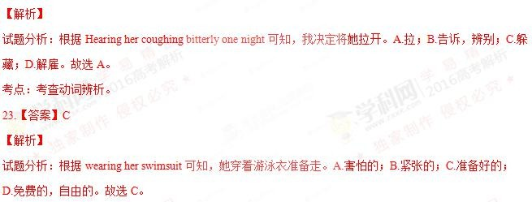

24.【答案】C

【解析】

试题分析：根据 I told her she shouldn’t swim after a whole night’s coughing 可知，她拒绝放弃，坚持要走。

A.脱下，起飞；开始流行；B.启程，引发；C.放弃；D.出现。故选 C。 考点：考查动词短语辨析。

25.【答案】B

【解析】

试题分析：根据 keep swimming 可知，Cathy 一直在训练，没有错过一次训练。A.参加；B.错过；C. 禁止；

D. 开始。故选 B。 考点：考查动词辨析。

26.【答案】C

【解析】

试题分析：根据上文 Cathy 一直在训练，没有错过一次训练可知，她的内心有坚定的意志。A.富有的；B.

虚弱的；C.坚定的； D. 好心的。故选 C。 考点：考查形容词辨析。

27.【答案】B

【解析】

试题分析：根据下文 with a passion and a mission 可知，我十岁的女儿成长为一个有决心的人。A.信任的；

B.有决心的；C.有经验的； D. 尴尬的。故选 B。 考点：考查形容词辨析。

28.【答案】A

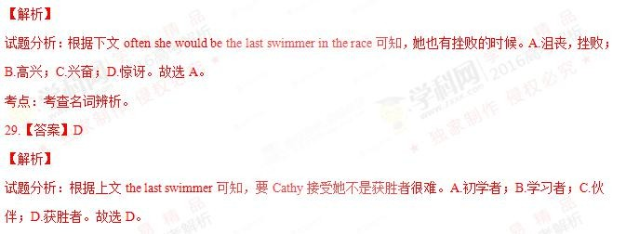

考点：考查名词辨析。

30.【答案】A

【解析】

试题分析：根据下文 praise their accomplishments 可知，Cathy 在那里为队友加油鼓劲。A.向……欢呼，为…… 鼓劲加油；B.和……竞争；C.回答；D.追赶。故选 A。

考点：考查动词短语辨析。

31.【答案】C

【解析】

试题分析：根据下文总教练说的话，可知，这里是指总教练宣布的事情。A.承认；B.解释；C.宣布；D.低语，

耳语。故选 C。 考点：考查动词辨析。

32.【答案】B

【解析】

试题分析：根据 enthusiasm 可知，教练说：是 Cathy 用她的意志力和热情激励了我们。A.幽默；B.意愿，意 志力；C.诚实；D.智慧。故选 B。

考点：考查名词辨析。

33.【答案】A

考 点：考查名词辨析。

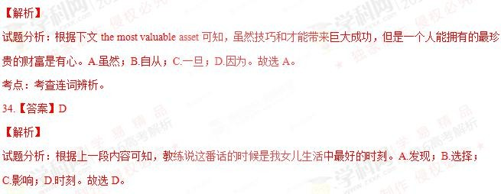

35.【答案】A

【解析】 试题分析：句意：这十年她经历的时候，是真正成功的时候。A.通过（内部），经历；B.在……下面；C.穿 过（表面）；D.在……周围。故选 A。

考点：考查介词辨析。

**2016** 江苏

【答案】36—40 DCDA B 41—45 BDAAD 46—50 BCABC 51—55 CCBAD

【解析】

36.D 考查动词辨析。根据＂for breakfast＂，可知我在吃早饭的时候遇见了 Kurt。故 D 项符合语境。

37.C 考查名词辨析。根据 42 空后＂You don’t have a personal plan for growth, do you?＂（对于个人成长你并没有 计划，是吧？）可知 Kurt 在问我个人成长计划是什么。故 C 项正确。

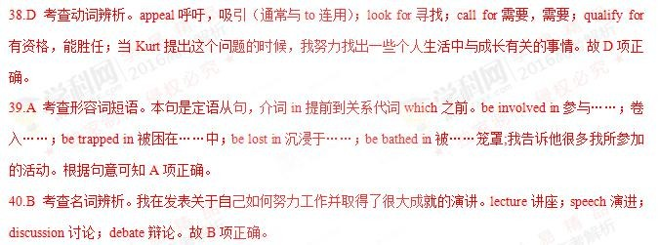

41.B 考查动词辨析。我讲了十分钟自己的个人努力及成就，Kurt 一直耐心地听我讲。故 B 项正确。

42.D 考查副词辨析。Kurt 耐心地听我讲了很长时间，最后他笑着对我说：“对于个人成长你并没有计划，是吧？”

eagerly 热切地；gr adually 逐渐地；gratefully 感激地；finally 最后。故 D 正确。



43.A 考查动词辨析。＂You don’t have a personal plan for growth, do you?＂是一个否定的反义疑问句，在回答的时 候＂No＂翻译为＂是的＂。说明我承认自己并没有个人成长计划。故 A 项正确。

44.A 考查形容词辨析。automatic 自动的；slow 缓慢的；independent 独立的；changing 不断变化的；Kurt 告诉我 成长并不是一个自动的过程，一定要有计划性，有计划的个人成长才是有效的成长。从那以后我意识到自己在这 方面的缺乏并作出改变。故选 A 项。

45.D 考查动词辨析。Kurt 的话触动了我，我的确没有有意识地做一些事情让自己变得更好。故 D 项正确。

46.B 考查介词辨析。on loan 暂借；on purpose 故意地；on sale 降价出售；on balance 总的来说。他的话让我意识 到自己的确没有有意识地做一些让自己变得更好的事情。故 B 项正确。

47.C 考查名词辨析。comment 评论； announcem ent 通告；decision 决定；arrangement 安排。此处是说，我做出 了一个决定：要为我的生活做一个个人的成长计划。故 C 项正确。

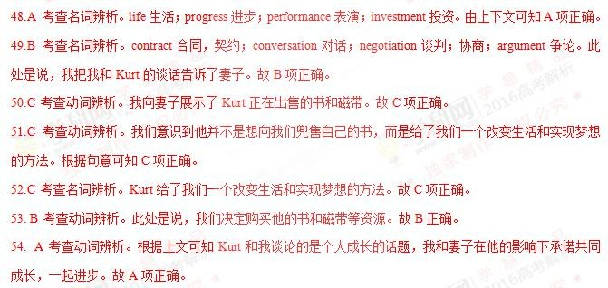

55. D 考查形容词辨析。由 While too many couples grow apart, we were growing together.可知我和妻子一起成长。 说明他的资源对我们有很大的帮助，我们做出的是一个明智的决定。故 D 项正确。

考点：考查记叙文阅读

**2016** 浙江

【语篇解读】这是一篇记叙文。作者讲述自己为了离丈夫近一些，住在他所在的沙漠的军营里，寂寞的生活和艰 苦的生活条件让作者难以忍受，她写信告诉父母要回家。父亲给她的信中就两行字，就是这两行字使作者改变了 自己对人生的态度。

21.【答案】C

【解析】 试题分析：根据上下文可知，作者去住在那儿是为了靠近丈夫。A.远离；B.在……后面；C.靠近；D.超过。 故选 C。

考点：考查介词辨析。

22.【答案】A

考 点：考查形容词辨析。

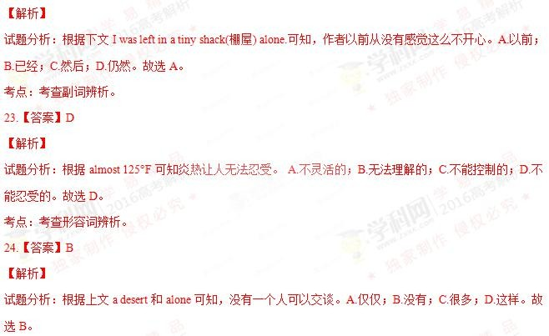

25.【答案】B

【解析】

试题分析：根据上文 a desert 可知，作者吃的食物、呼吸的空气都充满了沙子。A.覆盖；B.填满；C.埋葬；

D.负责，要价。故选 B。

考点：考查动词辨析 。

26.【答案】C



【解析】

试题分析：根据下文 coming back home，可知，作者写信给父母，告诉他们她要放弃，要回家。A.赶上；

B.维持；C.放弃；D.起床。故选 C。 考点：考查动词短语辨析。

27.【答案】C

【解析】

试题分析：根据上文 I said I couldn’t stand it one minute longer 可知，我宁愿在监狱里。A.应该；B.很可能；

C.宁愿；D.最好。故选 C。 考点：考查短语辨析。

28.【答案】D

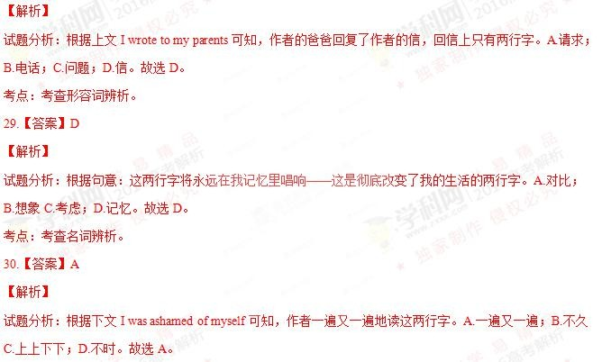

考点：考查短语辨析。

31.【答案】C

【解析】

试题分析：根据上文 I would look for the stars 可知，作者决定要发现在现在的境况中好的东西。A.公司，陪

伴；B.占据，职业；C.境况；D.关系。故选 C。 考点：考查名词辨析。

32.【答案】B

【解析】

试题分析：根据下文 They gave me presents of their favorite artworks which they had 33 to sell to tourists 可 知，作者和当地人交朋友，他们的反应让作者很惊讶。A.运动；B.反应；C.指导；D.目的。故选 B。 考点：考查名词辨析。

33.【答案】A

【解析】 试题分析：根据句意：他们给我最喜欢的艺术作品的礼物，这些作品是他们拒绝卖给游客的。A.拒绝；B. 失败；C.设法完成；D.碰巧。故选 A。

考点：考查动词辨析。

34.【答案】B

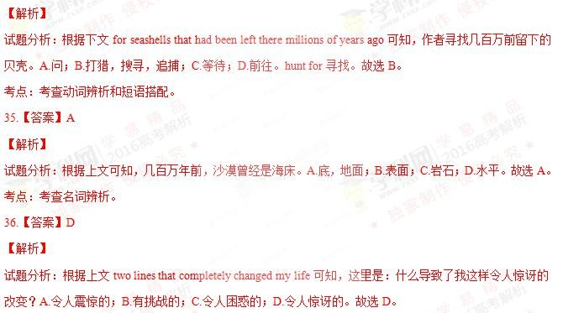

考点：考查形容词辨析。

37.【答案】B

【解析】

试题分析：根据句意：沙漠没有改变，但是我变了。A.正如，因为，随着；B.但是；C.因为；D.或者。此处 表示转折关系，故选 B。

考点：考查连词辨析。

38.【答案】A

【解析】

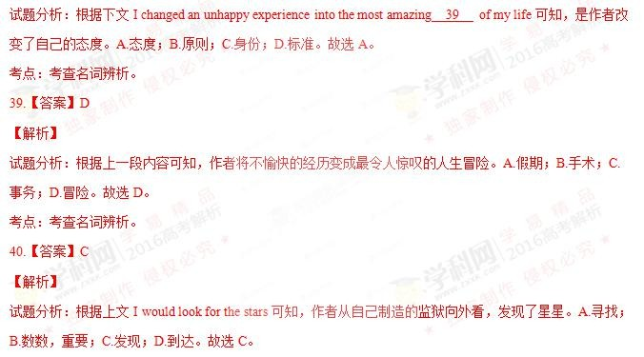

考点：考查动词辨析。

**2015** 全国卷 **1**

【答案】

41. A 42. C 43. B 44. A 45. D

46. C 47. D 48. B 49. A 50. D

51. A 52. C 53. B 54. B 55. A

56. D 57. C 58. D 59. C 60. B

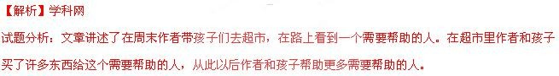

41．A 考查动词以及对语境的理解。A. Lose 失去；B. Changed 改变；C. Quit 放弃； D. Finished 完 成。短语 lose one’s job 失业。在路上，我们注意到一个男人握着一张纸，纸上写到：“失业，需要养家。” 答案 选 A。

42．C 考查名词以及对语境的理解。A condition 状况；B. place 地方；C. sight 情景； D. show 展示。在这家商 店，像这样的场景并不正常。选 C。

43．B 考查名词以及对语境的理解。A. suggestion 建议；B. comment 评论；C. decision 决定；D. call 电话。make a comment on 对……发表看法。我 10 岁的孩子注意到他，并评论说在寒风中站在外面一定很糟糕。故选 B。

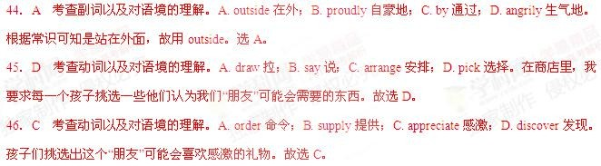

47．D 考查动名词以及对语境的理解。A. dollar 美元；B. job 工作；C. hot meal 热餐；D. gift card 礼物卡。根据 下文提示可知，我 17 岁的孩子建议给他一张礼物卡。选 D。

48．B 考查形容词以及对语境的理解。A. easy 容易的；B. low 低的；C. soft 柔软的；D. loose 松的。根据下句 的意思可知“我们现金不足或缺乏 ”，low 意思“少，低”。选 B。



49．A 考查动词以 及对语境的理解。A. giving 给予；B. saving 节省；C. spending 花费；D. begging 恳求。我们 把我们不充足的东西给予别人，而不是充足的东西，正是我们真正需要去做的。选 A。



50．D 考查副词以及对语境的理解。A. yet 然而；B. even 甚至；C. still 任然；D. just 刚刚。仅仅是我们需要做

的。选 D。

5 1．A 考查动词以及对语境的理解。A. declared 宣告；B. shared 分享；C. ignored 忽视；D. expected 期望。所 有的孩子声明了他们能够为这个周末放弃自己想要的东西。选 A。



52．C 考查名词以及对语境的理解。A . toys 玩具；B. medicine 药；C. food 食物；D. clothes 衣服。根据上文 的 apples, sandwich and a bottle of juice 可知是食物。选 C。

53． B 考查形容词以及对语境的理解。A. sleepy 瞌睡的；B. watery 潮湿的；C. curious 好奇的；D. sharp 锋利的。 带着潮湿的双眼感谢我们。选 B。

54．B 考查代词以及对语境的理解。A. whoever 无论谁；B. whatever 无论什么 C. whichever 无论哪一个；D. whenever 无论什么时候。动词 need 缺少宾语，故用 whatever。他可以给我打电话，无论他的家人需要什么。故 选 B。

55．A 考查名词以及对语境的理解 。A. experience 经历；B. example 例子；C. message 信息；D. adventure 冒险。 这对我们家庭是一次极好的经历。选 A。



56．D 考查动词及短语以及对语境的理解。A. rely on 依靠；B. respect 尊敬；C. learn from 从……学到；D. help

帮助。多少天来，孩子们一直在寻找我们能够帮助的其他人。选 D。

57．C 考查副词以及对语境的理解。A. suddenly 突然；B. vividly 生动地；C. differently 不同地；D. perfectly

完美地。事情发生得如此的不同。 选 C。

58．D 考查名词以及对语境的理解。A. time 时间；B. power 权力；C. patience 耐心；D. money 金钱。我们真的 不需要给更多的钱。所以选 D。

59．C 考查名词以及对语境的理解。A. fear 害怕；B. love 爱；C. need 需要；D. memory 记忆。in need 在危难中。 走出去不仅仅帮助在危难中的兄弟。选 C。

60．B 考查形容词以及对语境的理解。A. strong 强壮的；B. sweet 甜的；C. strange 奇怪的；D. simple 简单的。 也给予我孩子们帮助他人的甜蜜的滋味。选 B。

考点：考查故事类完形填空

**2015**全国卷**2**

【答案】

41. B 42. C 43. D 44. C 45. B

46. A 47. D 48. D 49. B 50. C

51. A 52. B 53. D 54. A 55. C

56. A 57. B 58. D 59. A 60. C

【解析】

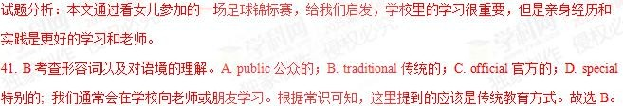

42. C 考查动词以及对语境的理解。A. passes 传递；B. works 起作用；C. lies 在于； D. ends 结束。本句应该分析 句子结构：the learning 后是定语从句 you really want，所以这里所填的是做谓语的动词。真正想要的学习却不在 上述的这些地方，在其他的地方。故选 C。

43. D 考查名词以及对语境的理解。A. dream 梦想；B. idea 想法；C. habit 习惯；D. chance 机会。根据下文的故事 可知，我女儿的经历让我有机会看到了这样的学习。故选 D。

44. C 考查名词以及对语境的理解。A. trip 旅行；B. holiday 假期；C. weekend 周末；D. square 广场。从下文的周 六的比赛会很艰苦和 It seemed that something clicked with the 51 between Saturday and Sunday.可知，是周末发 生的事。故选 C。

45. B 考查动词以及对语境的理解。A. won 赢；B. entered 进入；C. organized 组织；D. watched 观看。从下文可 知，女儿所在的足球队打得好所以进入了锦标赛。故选 B。

46. A 考查形容词以及对语境的理解。A. painful 痛苦的；B. strange 奇怪的；C. common 普通的；D. practical 实用 的。由语境可知，对手比作者女儿的队 better trained，可以推断这将是一场痛苦的比赛。故选 A。

47. D 考查副词以及对语境的理解。A. less 少于；B. poorly 差的；C. newly 新的；D. better 更好的。 根据常识可 知，进入锦标赛的一般都是训练更好的队伍。故选 D。

48. D 考查名词以及对语境的理解。A. fans 粉丝；B. tutors 教练；C. class 班；D. team 队。根据上下文可知，是女 儿所在的足球队没进球得分。故选 D。

49. B 考查动词以及对语境的理解。A. imagined 想象；B. hated 不喜欢； C. avoided 避免；D. missed 想念，错过。

作为家长，一般都不会喜欢看自己的孩子尽力了，又要输。故选 B。

50. C 考查连词以及对语境的理解。A. if 如果；B. or 或者；C. but 但是；D. as 因为。根据上文可知，没进球，自 己的孩子尽力了却要输，这是作为家长所不愿意看到的。表转折，故选 C。

51. A 考查名词以及对语境的理解。A. girls 女孩；B. parents 家长；C. coaches 教练；D. viewers 观众。本文一直在 说女儿，当然应该是说女孩子们的变化。故选 A。

52. B 考查动词以及对语境的理解。A. dressed 给……穿衣服；B. showed up 出现；C. made up 编造；D. planned

计划。从下文可知，周日和周六的表现完全不同。故选 B。

53. D 考查副词以及对语境的理解。A. slightly 轻微地；B. hardly 几乎不；C. basically 基本地；D. completely 完全 地；根据后面文章可知，这些孩子们表现和之前完全不同，completely 符合语境。选 C。

54. A 考查动词以及对语境的理解。A. seen 看；B. known 知道；C. heard 听到；D. read 读。她们把她们亲眼所 看到的球队的打法运用到自己的比赛中。故选 A。

55. C 考查名词以及对语境的理解。A. styles 风格；B. training 训练；C. game 比赛；D. rules 规则。她 们把前一天在赛场上看到的打法和团队精神运用到自己的赛场上。所以才和以前不同。故选 C。

56. A 考查副词以及对语境的理解。A. even 甚至；B. still 仍然；C. seldom 很少；D. again 又。她们和前一场比， 打得有闯劲，甚至还得了一分。故选 A。

57. B 考查动词以及对语境的理解。A. confused 使困惑；B. struck 击打；C. reminded 提醒；D. warned 警告。It strike sb.是固定句式，意思是让某人突然想到，符合语境。故选 B。

58. D 考查动词以及对语境的理解。A. touching 接触；B. thinking 思考；C. encouraging 鼓励；D. learning 学习。 和另一个队比赛也是一个很好的学习的机会。和文章的开头相呼应。故选 B。

59. A 考查名词以及对语境的理解。A. Experience 经历；B. Independence 独立；C. Curiosity 好奇；D. Interest 兴趣。 结合全文的意思可知，经历是最好的老师。故选 A。

60. C 考查动词以及对语境的理解。A. harmful to 对……有伤害；B. mixed with 混合；C. different from 不同；D. applied to 应用于。亲身体验得到的东西和在学校里学到的可能不同，但是更有个性有意义。故选 C。

【考点定位】教育类短文阅读。

【名师点睛】本文是一篇夹叙夹议的短文。这样的短文是大多数考生难以把握的。不过，这样的文章通常在开头 和结尾处点睛，评论。中间叙事。以第三人称的形式转述，一定会有个人的观点包括在内。所以考生要认真分析 是什么事引发了怎样的思考或评论，即事件和议论是两条线。另外平时多做多分析一些这类题会有很大的帮助。

**2015** 北京卷

【解析】

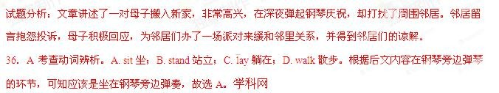

37. C 考查名词辨析。A. voice 声音；B. ring 铃声；C. music 音乐；D. cry 哭声。考查前文细节 jazzmusic 的原词 复现，是音乐充满了房间。故选 C。

38. B 考查副词辨析。A. therefore 因此，所以；B. however 然而；C. otherwise 否则；D. instead 代替。通过上一 段的欢乐幸福气氛和下文的幸福一下子 disappeared 的强烈对比可知，本处需要一个逻辑关系为转折的副词，故 选 B。

39. A 考查名词辨析。A. note 笔记；B. poster 海报；C. bill 账单；D. report 报告。本题是一道同义词复现题， 通过文章倒数第 5 段处得知，是由 Mrs.Gilbert 留了 一张字条，故选 A。



40. D 考查形容词辨析。A. proud 骄傲的，自豪的；B. rich 富裕的；C. lucky 幸运的；D. nice 美好的，愉快的。 主人公想向管理员咨询，哪一位邻居可能是那位留言的抱怨者，由转折词 But 可知管理者也并不能指出，由此可 知大家通常都是通情达理的，故选 D。

41. A 考查名词辨析。A. neighbors 邻居们；B. friends 朋友们；C. relatives 亲属，亲戚；D. audiences 听众。此 题线索明显，全文都是围绕主人公和周围邻居展开 的，故选 A。



42. D 考查动词辨析。A. blame 归咎于，指责；B. instruct 通知，命令；C. question 询问，质问；D. visit 参观， 拜访。由上文可知，母子两人对于扰民之事十分抱歉，想要去道歉，因此“指责”、“指导”和“质问”都不符合语境， 故选 D。

43. A 考查名词辨析。A. party 聚会；B. concert 音乐会；C. show 展览；D.play 游戏，比赛。此题为线索题且 为原词复现，由后文可知母子为解决此事办了一场派对，并邀请了邻居们，故选 A。

44. B 考查名词辨析。A. experience 经历，经验；B. idea 主意；C. performance 表演；D. action 行为。此题可排 除得知，母子打算办派对，这是一个打算，一个主意，而不是经历、表演表现或行为。故选 B。

45. C 考查介词辨析。A. to 到；B. with 伴随着；for 为了；D. from 来自。母子办派对，准备了甜点是为了招待 客人们，介词 for 有表“为了”的含义，故选 C。

46. B 考查动词辨析。A. continue 继续；B. arrive 到达；C. pass 通过；D. finish 完成。根据上文，他们举办了

一次聚会，准备许久，这一天终于到来了，故选 B。

47. C 考查动词辨析。A. order 命令，点菜；B. sell 买；C. share 分享；D. advertise 做广告。根据本句话的意思： 甚至有人带了甜点来分享，故选 C。

48. B 考查动词辨析。A. treat 招待，治疗；B. present 呈现；C. help 帮助；D. serve 为……服务。这道题有难度， 根据本句话的意思：Mrs.Gilbert 送给了 Dario 的妈妈一本音乐书 ，能表达出“送”这个动作的，就是 present“呈现…， 给…”，故选 B。



49. D 考查动词辨析。A. promise 承诺；B. admit 许可进入；C. agree 同意；D. serve 服务。根据题意，Mrs.Gilbert

之所以留了一张抱怨小纸条是担心每天晚上都会这么吵，故选 D。

50. D 考查动词辨析。A. give 给；B. send 发送；C. offer 提供；D. owe 感激，欠……债。这个空可以看作是固 定搭配，owe sb. an apology 应该向某人道歉。故选 D。

51. A 考查动词辨析。A. realize 意识到；B. remember 记起；C. understand 理解，懂的；D. accept 接受。Dario

的妈妈道歉说：我也没意识到当时那么晚了我们还在弹钢琴。应该选择“意识到”这个动词，故选 A。

52. D 考查形容词辨析。A. sweet 甜的；B. strange 奇怪的，陌生的；C. funny 滑稽的；D. loud 声音大的，吵 闹的。根据上一句：I like what you play! Just not so loud at night.说明 Mrs. Gilbert 不喜欢那么吵的音乐，因此她送 了 Dario 的妈妈一本比较安静的音乐书，也就是不那么吵的音乐(not such loud music)。故选 D。

53. C 考查形容词辨析。A. brave 勇敢的；B. sorry 抱歉的；C. happy 快乐的；D. afraid 害怕的。通过上文：These songs are beautiful music, 说明 Dario 的妈妈很喜欢这些音乐，所以 we will be happy to play them。故选 C。

54. B 考查动词辨析。A. change 变化；B. practice 练习，实践；C. record 记录；D. write 写作。根据题意，应 该是练习音乐，故选 B。

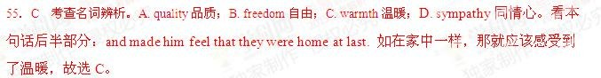

考点：故事类阅读

**2015** 天津

【解析】

试题分析：文章大意：作者和未婚夫准备买房结婚，但是资金有限。一次作者对一个房子一见钟情，但价格仍然 很高，但通过最后的努力，作者以很低的价格买到了此房。

16．B 考查动词以及对语境的理解。A．needed 需要的；B．limited 有限的；C．enough 足够的；D．large 大的。 根据下一句中的 and none of the houses in our price range seemed satisfactory.”可知答案选 B。

17．A 考查动词以及对语境的理解。A．recommended 推荐；B．decorated 装修；C．sold 卖； D．rented 租。 根据后句 Although her description sounded wonderful 可知一个代理人特别向我们推荐一栋房子。选 A。

18．C 考查介词以及对语境的理解。A．below 在……下面；B．within 在……里面；C．beyond 超过；D．between

在……之间。根据后句 so we declined.可知价格超过了我们的范围。故选 C。

19．A 考查短语以及对语境的理解。A．at least 至少；B．at most 至多；C．at times 有时；D．at hand 在附近。 但她不停的催促我们至少去看一看。选 A。

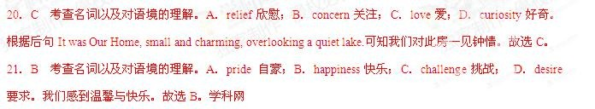

22．D 考查名词性从句以及对语境的理解。A．which 哪一个；B．why 为什么；C．that 那个；D．what 什么。 宾语从句中 be like 缺少宾语，故用关系词 what。选 D。

23．B 考查名词以及对语境的理解。A．effort 努力；B．offer 提供；C．promise 许诺； D．profit 利润。根据 后句—far below the asking price 可知是 make an offer 出价。选 B。

24．D 考查短语以及对语境的理解。A．come across 偶然遇到；B．look after 照顾；C．depend on 依靠； D．laugh at 嘲笑。令人惊讶的是，他们没有嘲笑我们。选 D。

25．A 考查副词以及对语境的理解。A．instead 相反 B．indeed 的确；C．aside 在……旁；D．apart 分开地。 相反地，他们更新了他们的出价。选 A。

26．C 考查形容词以及对语境的理解。A．worse 更糟的；B．better 更好的；C．less 更少的；D．higher 更高的。 但比原来的要价要少得多。选 C。

27．B 考查形容词以及对语境的理解。A．relaxing 轻松的；B．disappointing 令人失望的；C．pleasant 令人愉快 的；D．regular 有规律的。第二天，我们得到一个令人失望的消息。选 B。

28． D 考查名词以及对语境的理解。A．agents 代理人；B．buyers 买方；C．managers 经理；D．owners 物主。

因此，我们决定直接跟房东谈。选 D。

29．B 考查副词以及对语境的理解。A．already 已经；B．still 任然；C．generally 普遍地； D．ever 曾经。我 们做出最终的价格，任然比其他买家出价少很多。故选 B。

30．D 考查连词以及对语境的理解。A．so 如此；B．or 或者；C．for 为了； D．but 但是。前后句为转折关 系，故用连词 but。选 D。

31．D 考查动词以及对语境的理解。A．apologized 道歉；B．complained 抱怨；C．criticized 指责；D．explained

解释。后面为房主解释的内容。选 D。

32．C 考查动词以及对语境的理解。A．check 检查；B．analyze 分析；C．appreciate 感激；欣赏； D．ignore

忽视。其原因是我们欣赏他们投入家庭多年的努力。 选 C。

33．A 考查名词以及对语境的理解。A．loss 损失；B．risk 冒险；C．chance 机会；D．lead 带领。根据上下文 可知把房子卖给我们他将会有损失，所以选 A。

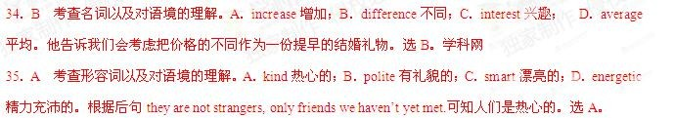

考点：记叙类短文阅读。

**2015** 江苏

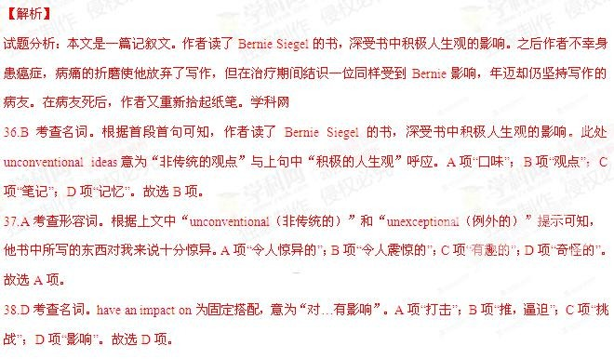

39.C 考查动词短语。根据下文可知，作者不幸身患癌症，病痛的折磨使他放弃了写作。但病友的执着和 Bernie Siegel 积极的人生观让自己又重新拾起纸笔，渡过了这段艰难时期。A 项“从……中获取经验，汲取教训”；B 项“复习， 仔细检查”；C 项“渡过难关”；D 项“提到，涉及，参考”。故选 C 项。

40.B 考查名词。根据下文中“…, I lost my drive to write”可知，作者是一名抱负的作家。A 项“读者”；B 项“作家”；

C 项“编辑”；D 项“医生”。故选 B 项。

41.A 考查形容词。句意：尽管我是一个积极的人，还是失去了写作的动力。a positive person 与 lost my drive to write 构成让步关系，且与上文 positivity 呼应。 A 项“积极的”；B 项“称心如意的”；C 项“幽默的”；D 项“诚实的”。故 选 A 项。

42.A 考查名词。句意：我就是感觉太累，没有心情去写。in the mood 意为“没有心情去做事”。A 项“心情”；B

项“位置，职位”；C 项“状态”；D 项“方式”。故选 A 项。

43.D 考查名词。句意：一天，当我在等待治疗时，手里拿着 Bernie 的一本书。A 项“建议”；B 项“提及，参考”；



C 项“保护”；D 项“治疗”。故选 D 项。

44.C 考查动词。句意：另外一个病人注意到我在读些什么，主动跟我攀谈起来。A 项 “认为”；B 项“知道，了解”；

C 项 “（无意中）注意到”；D 项 “想知道”。故选 C 项。

45.B 考查连词。句意：该空后是他主动和我攀谈的原因：他身上也有一本 Bernie 的书。A 项表示时间或轻微转 折；B 项表示原因；C 项表示让步；D 项表示条件。故选 B 项。

46.D 考查动词短语。除此之外，他是一位八十岁的作家。A 项 “出现，出版”；B 项“锻炼，解决，制定”；C 项“证 明是合适的，令人满意的”；D 项“证明是，结果是”。it turned out that 是固定搭配，意为“结果是……，结果证明……” 故选 D 项。

47.D 考查副词。句意：事实上，他是一位撰稿人，目前在写一本新书。A 项 “自然地”；B 项“仅仅”；C 项“有希 望地”；D 项“事实上”。故选 D 项。

48.C 考查动词搭配。根据句意可知，他目前在写一本新书。A 项 decide on“决定，确定”；B 项 invest on“投资， 花时间在……上”；C 项 work on“从事，忙于”；D 项 rely on“依赖，依靠”。故选 C 项。

49.A 考查动词。句意：我们总是在许多时候见到对方，成了朋友。A 项 “成为”；B 项“帮助”；C 项“错过”；D 项

“拜访”。故选 A 项。

50.C 考查名词。根据句意可知，他的确是 Bernie 的粉丝。A 项 “病人”；B 项“操作员，接线员”；C 项“粉丝”；D

项“出版商”。故选 C 项。

51.B 考查名词。根据句意可知，他的举动感染了我，使我在生活中面带微笑。A 项 “标志，迹象，征兆”；B 项“微 笑”；C 项“标记”；D 项“面罩”。故选 B 项。

52.D 考查动词短语。句意：他补充说道 Jason 因为不愿说谎没挣到钱。A 项 “出现，露面”；B 项“出发，动身”；

C 项“跌倒”；D 项“去世（死的委婉表达）”。故选 D 项。

53.B 考查连词。句意：他去年不幸死于癌症，但给我留下了深刻的印象。A 项表示时间；B 项表示转折；C 项表 示结果；D 项表示原因。故选 B 项。

54.D 考查名词。句意：他激励我重新拾起纸笔。A 项 “指导”；B 项“信任”；C 项“机会”；D 项“鼓舞，激励，启 发”。故选 D 项。

55.C 考查名词。句意：我对自己说：“如果他能做到，我也能。”A 项 “承诺”；B 项“郑重发誓”；C 项 think to oneself

“自言自语”；D 项“回答”。故选 C 项。 考点：记叙文阅读

**2015** 浙江

26.

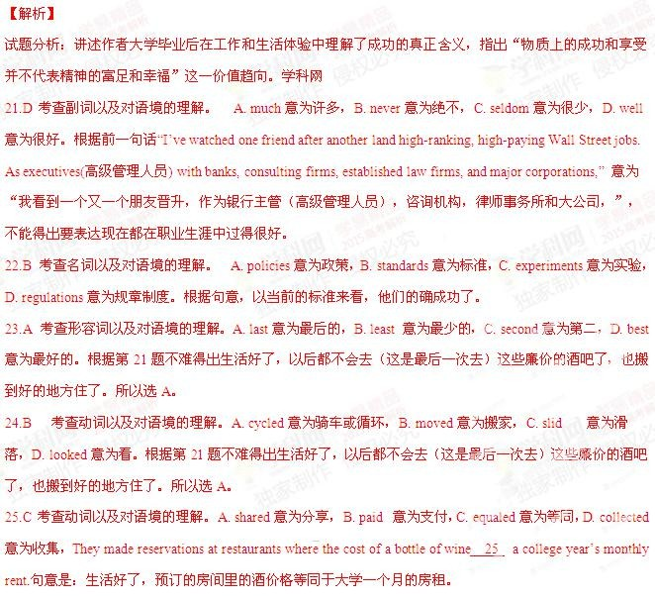

29.D 考查形容词以及对语境的理解。A. calm 意为平静，B. guilty 意为有罪的，C. warm 意为温 暖，D. empty 意

为空的，累的。根据前面的 tired 累不能得出答案。Some do not respect the companies they work for and talk of feeling tired and 29 。意为有些人不尊重他们工作的公司，说累。



30.C 考查名词以及对语境的理解。A. family 意为家庭，B. government 意为政府，C. lifestyle 意为生活方式，D. project 意为项目。前文提到很多都是生活，如学校生活，工作生活，结合语境不能得出答案是生活方式。

31.A 考查形容词以及对语境的理解。A. accustomed 意为习惯的，B. appointed 意为指定的，C. unique 意为独一无 二的，D. available 意为可利用的。“However, instead of devoting themselves to their work, they find themselves working to support the 30 to which they have so quickly become 31 . 意为“但是，不是全身心投入于工作，他 们发现工作只是支持生活方式，而且慢慢他们已经对这种方式已经行习惯了。”

32.A 考查连词以及对语境的理解。A. yet 意为但是，表转折，B. also 意为也，表递进，C. instead 意为 代替，D. rather 意为相反。此句是长难句。意为：人们总是说走一种满意的道路，但是最后，离开现在的工作去 做一些他们相信或者是一种可以和家人在一起的职务的想法最终都得出一个这样的结论：这是不可能的。根据句 意，前后是转折的关系，所以选 A。



33.D 考查动词以及对语境的理解。A. let out 意为发出，B. turn in 意为上交，归还，C. give up 意为放弃，D. believe in 意为相信。此句是长难句。意为：人们总是说走一种满意的道路，但是最后，离开现在的工作去做一些他们相 信或者是一种可以和家人在一起的职务的想法最终都得出一个这样的结论：这是不可能的。

34.C 考查形容词以及对语境的理解。A. fundamental 意为基本的，B. practical 意为实践的，C. impossible 意为不 可能的，D. unforgettable 意为难忘的。此句是长难句。意为：人们总是说走一种满意的道路，但是最后，离开现 在的工作去做一些他们相信或者是一种可以和家人在一起的职务的想法最终都得出一个这样的结论：这是不可能 的。

35.D 考查动词以及对语境的理解。A. take of 意为起飞，B. drop off 意为减少，C. put off 意为推迟，D. pay off

C 考查动词以及对语境的理解。A. advertise 意为广告，B. witnessed 意为目击，C. admitted 意为承认 D. demanded

意为要求。“The thing is, a number of them have 26 that despite their success, they aren’t happy.” 意为很多人承 认，尽管他们很成功，但是很不开心。

27.A 考查动词以及对语境的理解。A. complain 意为抱怨，B. dream 意为梦想，C. hear 意为听到，D. approve 意 为证明。根据上一句的不开心，所以不难得出答案是抱怨。

28.B 考查动词以及对语境的理解。A. distribute 意为分发，B. hate 意为厌恶，C. applaud 意为鼓掌，D. neglect 意 为忽略。根据上文的不开心和抱怨，不能得出答案是厌恶。

意为支付。根据 mortgage（抵押贷款）以及结合常识，不难得出答案。

36.A 考查动词以及对语境的理解。A. missing 意为失去，B. inspiring 意为鼓舞，C. sinking 意为沉没，D. shining 意为闪亮。句意是为他们意识到，在生活中失去 missin g 了一些什么，但是他们却很难离开这个轨迹。根据句意 不难得出答案。



37.B 考查形容词以及对语境的理解。A. harmful 意为有害的，B. hard 意为困难的，C. useful 意为有用的，D. normal 意为正常的。句意是为他们意识到，在生活中失去了一些什么，但是他们却很难 hard 离开这个轨迹。根 据句意不难得出答案。

38. A 考查动词以及对语境的理解。A. measure 意为衡量，B. suffer 意为遭受，C. digest 意为消化，D. deliver

意为运送。句意为当前的社会，人们趋向于用钱来衡量 measure 所有的事情，我们在很小的时候就知道，应该考 虑我们决定的经济代价。

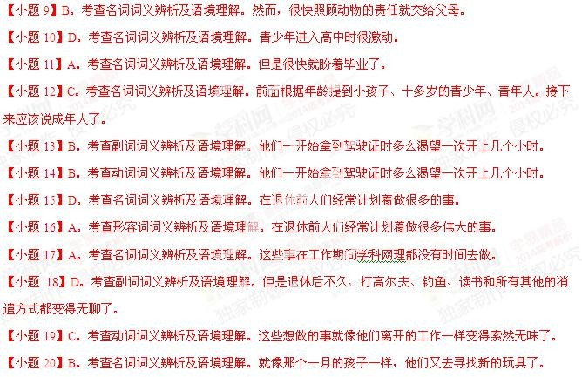

39.D 考查名词以及对语境的理解。A. disasters 意为灾难，B. motivations 意为动机，C. campaigns 意为战役，D. decisions 意为决定。句意为当前的社会，人们趋向于用钱来衡量所有的事情，我们在很小的时候就知道，应该考 虑我们决定 decisions 的经济代价。

40.B 考查动词以及对语境的理解。A. assessed 意为评估，B. involved 意为涉及，C. covered 意为覆盖，D. reduced 意为减少。Involved in 意为参与。句意为：那么，在追求钱高于意义的情况下，我们的参与的个人以及社会代价 呢？

考点：夹叙夹议的一篇文章

**2014** 全国卷 **1**

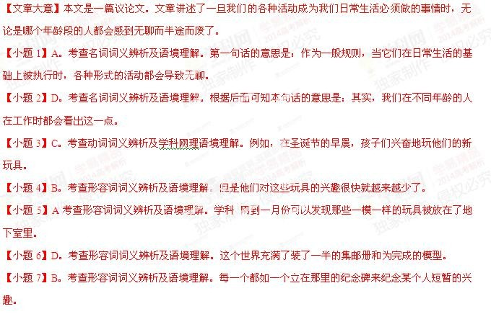

【小题 8】C。考查副词词义辨析及语境理解。当父母带回家一只宠物，他们的孩子高高兴兴地给它洗澡、给它

刷毛。

**2014** 全国卷 **2**

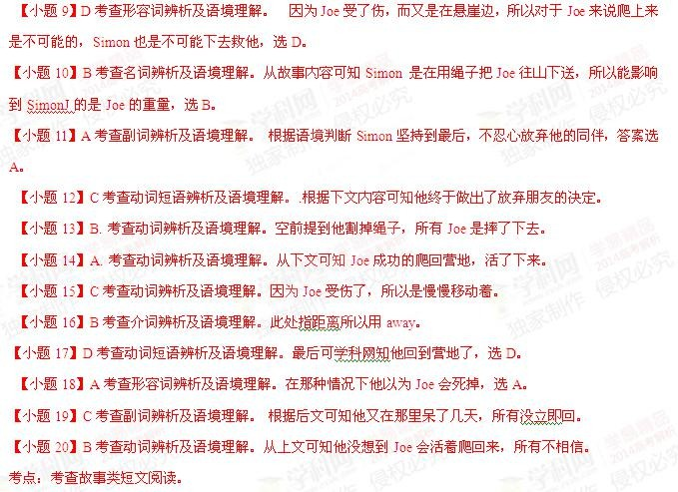

【解析】

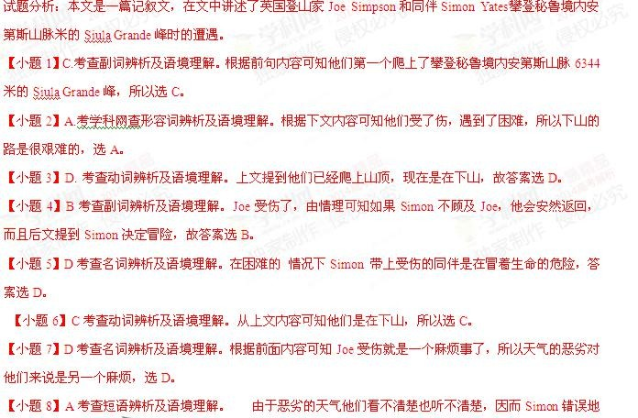

把 Joe 用绳子放到了悬崖边，答案选 A。

**2014** 大纲卷

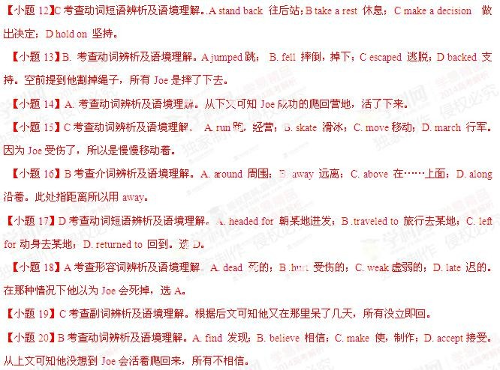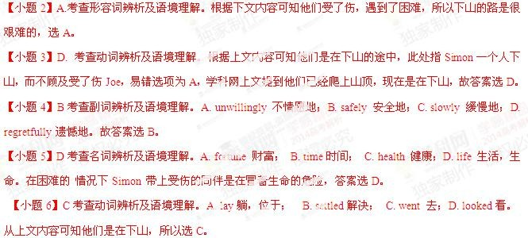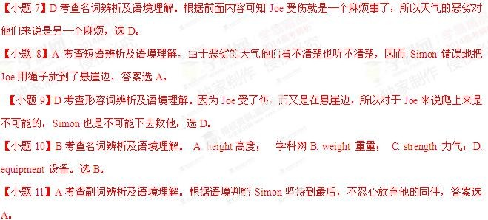

**2014** 浙江卷

【解析】

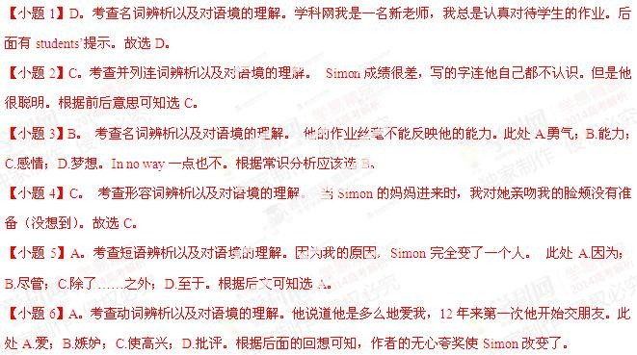

【小 题 17】D。考查动词辨析以及对语境的理解。都是因为他碰巧是最后一排最后一个孩子。

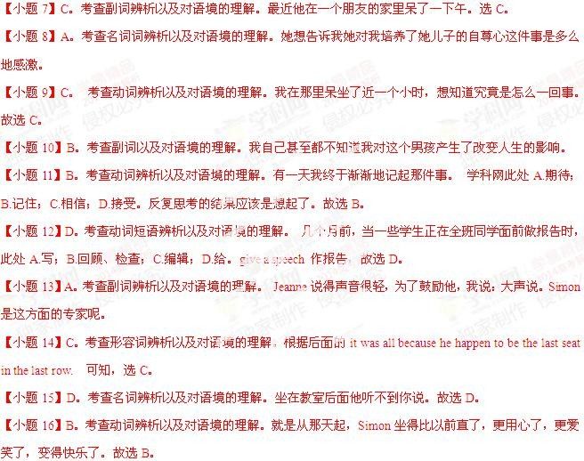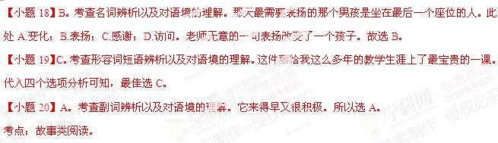

**2014** 北京卷

36.A 考查动词词义辨析及语境理解。班上的男孩常常开她的玩笑。故选 A。此处 joke 意为：开玩笑。

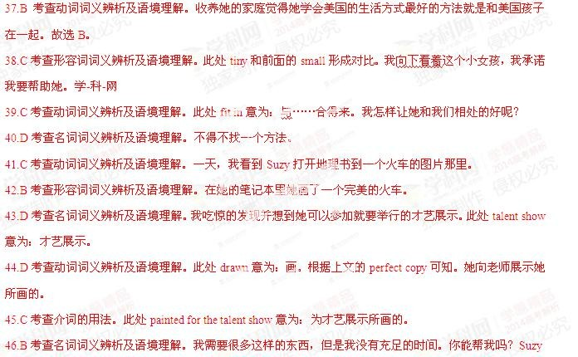

47.D 考查名词词义辨析及语境理解。根据前面的 poster 可知，此处选 poster。这里是反指法。她的海报在学校到 处都是，而且各不相同。

48.A 考查名词词义辨析及语境理解。此处 special 意为：特殊。我们设立一个特殊的奖励。

49.A 考查动词辨析及语境理解。那些海报是我们自己的学生画的。

50.B 考查副词词义辨析及语境理解。此处 that 是副词，意为：如此。我们学校谁能画的这么好呢？

