美国前总统奥巴马又出新书了｜纽约时报
美国前总统奥巴马又出新书了。
当地时间11月17日，奥巴马的第四部著作、卸任后首部回忆录《应许之地》（A Promised Land）第一卷正式上架，这本厚768页的回忆录涵盖了从他童年到2011年击毙本·拉登期间的诸多细节，尚未面世的下一卷预计将涉及叙利亚内战、克里米亚危机等问题。
“应许之地”出自圣经《旧约·创世纪》：以色列人祖先亚伯拉罕由于虔敬上帝，上帝与之立约，应许其后裔将拥有流淌牛奶与蜜之地——迦南（约旦河以西地区，包括加利利海以南和死海以北地区）。奥巴马书名中的“应许之地”指的则是美国。
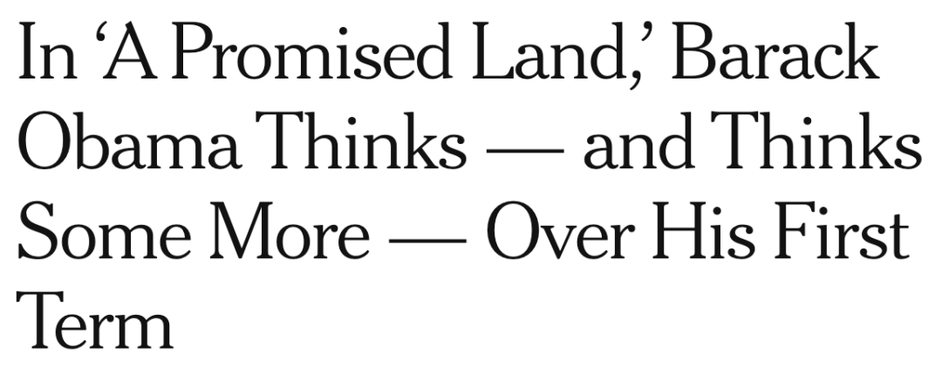
The most audacious thing about Barack Obama’s new memoir, “A Promised Land,” is the beaming portrait on its cover: There he is, the 44th president, looking so serenely confident that it’s as if the book weren’t arriving on the heels of a bitter election, amid a cratering economy and a raging pandemic.
贝拉克·奥巴马(Barack Obama)的新回忆录《应许之地》(A Promised Land)的最大胆之处，就是封面上他那容光焕发的肖像：这位第44任总统看上去是如此平静自信，仿佛这本书并非是在一场痛苦的选举之后，在经济萧条和疫情肆虐的情况下出版的。
The ebullient image also stands at odds with the narrative inside — 700 pages that are as deliberative, measured and methodical as the author himself. Obama says that he initially planned to write a 500-page memoir and be done in a year; what he ended up with instead is a hefty volume (now the first of an anticipated two) that stops in May 2011, shortly after his roasting of Donald Trump at the White House Correspondents’ Dinner on April 30 and the killing of Osama bin Laden the day after.
他兴高采烈的样子也与书中的叙述格格不入——这700页的作品与作者本人一样审慎、有分寸、有条不紊。奥巴马说他最初计划写一本500页的回忆录，并在一年内完成；但他最终完成的是一本长篇巨制（现在上市的是预计的两卷本的上卷），时间线停止在2011年5月，即他在4月30日的白宫记者晚宴上嘲讽唐纳德·特朗普(Donald Trump)以及次日奥萨马·本·拉登(Osama bin Laden)被击毙后不久。
第一，学会(hard/hot/close) on the heels of something的用法。这个词组表示very soon after something，紧接着某事、在某事后不久，例：The decision to buy Peters came hard on the heels of the club’s promotion to Division One. 该俱乐部刚升至甲级就作出了购买彼得斯的决定。第二，学会be at odds的用法。这个词组有两个含义：其一，表示to disagree，意见不一致、有分歧，例：Briggs found himself at odds with his colleagues. 布里格斯发现自己与同事们意见不合。其二，表示if two statements, descriptions, actions etc are at odds with each other, they are different although they should be the same，（说法、描述、行为等）不一致，例：Mark’s account of what happened is at odds with Dan’s. 马克对所发生情况的描述和丹的说法不一致。第三，学会measured /ˈmeʒəd $ -ərd/的用法。这个形容词表示if you do something in a measured way, you do it in a careful and controlled way, not in an excited or sudden way，慎重的、沉着的，例：a measured response to the problem 对问题作出的慎重回应。
Obama’s extraordinary first book, “Dreams From My Father,” was published in 1995, a year before he was elected to the Illinois senate, and traced his family history alongside his own coming-of-age. “A Promised Land” is necessarily less intimate and more political, offering close-up views of the major issues that Obama faced during his first term, including the economic stimulus, health care, immigration, the environment and the forever war in Afghanistan.
奥巴马的杰出处女作《我父亲的梦想》(Dreams From My Father)出版于1995年，那是他当选伊利诺伊州参议员的前一年，他在追溯自己成长历程的同时，也追溯了他的家族史。《应许之地》必然没有那种亲密，而更具政治色彩，对奥巴马在首个任期内面临的主要问题提供了近距离描写，包括经济刺激、医保、移民、环境和永无止境的阿富汗战争。
Presumably left for the future volume are, among other fraught subjects: the 2016 election, his abdication of his own “red line” in Syria, the entrenchment of the surveillance state and a discussion of drone strikes. This isn’t to say that “A Promised Land” reads like a dodge; if anything, its length testifies to what seems to be a consistently held faith on the part of the former president— that if he just describes his thinking in sufficient detail, and clearly lays outthe constellation of obstacles and constraints he faced, any reasonable American would have to understand why he governed as he did.
可以推测下卷的内容将包括其他令人困扰的话题：2016年大选、放弃了自己在叙利亚的“红线”、强化国家监视、以及对无人机袭击的讨论。这并不是说《应许之地》写得像一种开脱；如果有什么问题，也是它的长度证明了这位前总统似乎一贯秉持的信念——即若能详细描述自己的想法，并列出他所面临的一系列障碍制约，那么任何一个理性的美国人都必然能明白他为什么会那样治理国家。
第一，学会coming of age的用法。这个词组表示the point in a young person’s life, usually the age of 18 or 21, at which their society considers them to be an adult，成年（通常为18岁或者21岁）。第二，学会close-up的用法。这个词作名词，表示a photograph or part of a film in which the camera seems to have been very close to the picture it took，（照相或电影的）特写、特写镜头，例：a close-up of her face 她的脸部特写。这里是名词作定语，表示“特写的、近距离的”。第三，学会if anything的用法。这个词组表示used when you are adding something to emphasize what you have just said，要说有什么的话（倒是……），例：Sam didn’t seem too disappointed at losing. If anything, he seemed relieved that it was all over. 对于比赛失利，萨姆好像并不是太失望。要说有什么的话，他似乎觉得终于比完了，松了一口气。第四，学会a constellation of something的用法。这个词组表示a group of people or things that are similar，一群（相似的人）、一系列（相似的事物），例：a constellation of ideas 一系列想法。

Nearly every president since Theodore Roosevelt has written a memoir that covers his years in office; this one contains some inevitable moments of reputation-burnishing and legacy-shaping, though the narrative hews so closely to Obama’s own discursive habits of thought that any victories he depicts feel both hard-won and tenuous. An adverb he likes to use is “still”— placed at the beginning of a sentence, to qualify and counter whatever he said just before. Another favorite is “maybe,” as he reflects on alternativesto what happened, offering frank confessions of his own uncertainties and doubts. At a time of grandiose mythologizing, he marshals his considerable storytelling skills to demythologize himself. He addresses the book to the“next generation,” to young people who seek to “remake the world,” but the story he tells is less about unbridled possibility and more about the forces that inhibit it.
自西奥多·罗斯福(Theodore Roosevelt)以来，几乎每位总统都写过回忆录，涵盖自己的执政岁月；这本书有不可避免的声誉营销和塑造遗产的内容，尽管叙述手法与奥巴马自己的散漫思维习惯非常类似，以至于他所描述的任何胜利都让人感觉来之不易且很脆弱。他喜欢用“still”（不过）这个副词，放在句子开头，对他之前所说的加以限定和反驳。另一个他最爱用的词是“maybe”（也许），在对已发生事件的其他选择进行思考时，他会坦白自己的不确定和怀疑。在这个充满宏大的神话叙事的时代，他用自己超高的讲述技巧消除了自身的神话色彩。把他这本书献给“下一代”，献给那些想要“重塑世界”的年轻人，但他讲述的故事与其说是关于无限可能，不如说更多是关于抑制这种可能的力量。
第一，学会reflect on something的用法。这个词组表示to think carefully about something, or to say something that you have been thinking about，仔细思考，表达（意见），例：He had time to reflect on his successes and failures. 他有时间反思他的成功和失败。

